

**OBJECT-ORIENTED ANALYSIS & DESIGN**

Year 2 (2020/21), Semester 3

## SCHOOL OF INFOCOMM TECHNOLOGY

Diploma in Information Technology

**ASSIGNMENT 2**

**Duration: 27 Jul – 21 Aug 2020**

**Weightage: 40% of overall grade**

**Individual – 60%**

**Team – 40%**

**Format: Project, Report and Presentation**

**Deadline: 23 Aug 2020 (Sun), 23:59hrs**

**Penalty for late** 10% per day (including Saturday, Sunday

**submission:** and public holiday)

No submission will be accepted after

**28 Aug 2020 (Fri), 23:59hrs**

|  |  |  |  |  |  |
| --- | --- | --- | --- | --- | --- |
|  | **Module Group:** | | | | |
|  | **Name** | **Student Number** | **Individual Grade** | **Group Grade** | **Final Grade** |
| **1** | Lim Dao Jun | S10195591K |  |  |  |
| **2** | Lee Sutton | S10195583E |  |  |
| **3** | Gerald Tan Yuan Xin | S10196210C |  |  |
| **4** | Anderson Loke Hou ming | S10195290H |  |  |
| **5** | Fong Kai Liang | S10196491H |  |  |

**PickUp Now Taxi**

**Software Requirements Specification Document for**

**Dr Loy Company**

**version 6**

# Revision History

|  |  |  |
| --- | --- | --- |
| **Date** | **Version** | **Description** |
| **1 August 2020** | **1** | Updated class diagram , use case diagram and some use case descriptions based on the feedbacks and comments from assignment 1 |
| **9 August 2020** | **2** | Updated class and use case diagram based on assignment 2 specification. We also did our individual use case specification. Added in Assignment cover page |
| **16 August 2020** | **3** | Added in our first trial Sequence diagram and Test cases. |
| **20 August 2020** | **4** | Updated definitions, acronyms and abbreviations in the document based on our class diagram. Updated our story map. |
| **22-23 August 2020** | **5** | Finalising class diagram with operations, sequence diagram with correct sequence number, use case specification and test cases. |
| **23 August 2020** | **6** | Completed all requirements and specifications. |

# Table of Contents

1.4 Definitions, Acronyms, and Abbreviations 4

1.5 References 6

2 User Stories and Story Map 6

2.1 User Stories 6

2.1.1 {User Stories for KL} 6

2.1.2 {User Stories for Lee} 6

2.1.3 {User Stories for GT} 7

2.1.4 {User Stories for dj} 7

2.1.5 {User Stories for anderson} 7

2.2 Story Map 8

3 Use Case Model 9

3.1 Use Case Diagram 9

3.2 Brief Use Case Descriptions 10

3.2.1 {Use Case Descriptions for KL} 10

3.2.2 {Use Case Descriptions for Lee} 10

3.2.3 {Use Case Descriptions for Gerald} 11

3.2.4 {Use Case Descriptions for DJ} 11

3.2.5 {Use Case Descriptions for Anderson} 12

3.3 Use Case Specifications,Test Case and User Interface 13

3.3.1 Create Driver Account 13

3.3.2 Driver Accept Customer Booking 23

3.3.3 Create Customer Account 27

3.3.4 Make Booking 35

3.3.5 Make Payment 45

3.3.6 Cancel Booking 59

3.3.7 Driver E-Wallet 63

4 Class Diagram 69

5 Sequence Diagrams 72

5.1 Create Driver Account 72

5.2 Driver Accept Customer Booking 73

5.3 Create Customer Account 74

5.4 Make Booking 75

5.5 Make Payment 77

5.6 Cancel Booking 80

5.7 Driver E Wallet 81

Appendices 81

Appendix A – Interview Guide 81

Appendix B – Background Reading Notes 90

Appendix C – Other Tools Used 91

# Introduction

## Purpose

The purpose of this project is to create a system for the client, PickUpNow Taxi Company.

## Background

PickUpNow Taxi Company is a company in Singapore which provides people with taxi services as well as allowing people to provide taxi services. As transportation in Singapore becomes more in demand, the company has decided to make a system so that users can get transportation or/and provide transportation for others.

## Scope

In order to create the required system, we have interviewed the stakeholder to find out more about the system required. Through this interview, we were able to gain a better understanding of the required system and the necessary information required to create it. We have decided to add in a few features which we think will enhance the usability of the system. In this project, we have made a story map listing down all the functions we want in the system. We then created a use case diagram with all the new features . Following that, we came up with detailed case descriptions for the use cases

## Definitions, Acronyms, and Abbreviations

## Payment

paymentId - Refers to a unique identifier for transactions

payementDateTime - Refers to the date and time the transaction occurred

paymentMethod - Refers to the method of transaction

**Administrator**

adminId - refers to a unique identifier for administrators

**Gift Card**

giftCardCode - refers to a unique code of the gift card

giftCardAmount - refers to the amount of the gift card

**Review**

description - Refers to a brief description of the trip made by the customer

followUpAction - Refers to the action that is follow up by the administrator

**E-Receipt**

referenceNo - Refers to the reference number each E-Receipt will have

dateOfReceipt - Refers to the date the E-Receipt is sent

**Trip**

tripID - Refers to the unique identifier each trip

durationOfTrip - Refers to the duration of trip

**Booking**

bookingId - Refers to the unique identifier for each Booking

bookingDate - Refers to the date the Booking was made

pickUpPoint - Refers to the pick up location of the trip

destination - Refers to the drop off location of the trip

distance - Refers to the total distance of the trip

dateOfTrip - Refers to the date the trip commences

timeOfTrip - Refers to the time at which the trip starts

estimatedArrivalTime - Refers to the estimated time at which the destination is reached

numberOfPassenger - Refers to how many passenger are on that trip

fare - refers to the trip fare

reasonForCancellation - Refers to the reason for cancellation of Booking

Status - Refers to the status of Booking: ”Confirmed” ,“Cancelled” or “Pending”

**Customer**

customerId - Refers to the unique identifier for each customer

customerType - Refers to whether the customer is a premium user or not

totalDistance - Refers to the mileage the customer has accumulated

credits - Refers to the amount of money in the customer’s e-wallet

points - Refers to the amount of points a customer has accumulated

**Driver**

driverId - Refers to the unique identifier each driver has

bankName - Refers to the name of the bank the driver uses

accountNumber - Refers to the unique identifier a driver has for their bank account

CreditsEarned - Refers to the amount of credits each from driving customers

**Users**

name - Refers to the name of the user

contactNumber - Refers to the contact number for a user

emailAddress - Refers to the user’s email address

**Rating**

noOfStars - Refers to the average number of stars a user has received after being rated

**Vehicles**

licensePlateNumber - Refers to the Unique identifier for each Vehicle

brand - Refers to the Brand Name of the Vehicle

model - Refers to the Model Name of the Vehicle

capacity - Refers to the maximum number of passenger the Vehicle can carry

**Van**

bookingFee - Refers to the booking fee amount of the van

**ExcursionBus**

deposit - Refers to the deposit amount of the Excursion Bus

## References

**For background reading:**

1. [COMFORTDELGRO TAXI TO LAUNCH NEW “COMFORTRIDE” SERVICE](https://www.cdgtaxi.com.sg/documents/3166855/6494311/ComfortDelGro+Taxi+To+Launch+New+ComfortRIDE+Service/211e2475-7fab-e002-ccca-b4079e08699e)
2. [NETS and ComfortDelGro launch convenient in-app payment for NETS users](https://www.cdgtaxi.com.sg/documents/3166855/6494311/NETS+and+ComfortDelGro+launch+convenient+in-app+payment+for+NETS+users/c0f3e994-f4b0-0305-94dd-625e0a2f3b59)

# User Stories and Story Map

## User Stories

### As a Customer, I would like to be able to print the e-receipt I get after every ride

Student Name: Fong Kai Liang

Student ID: S10196491H

### As a Customer, I would like to be able reset my password in the case that I forget my password

Student Name: Fong Kai Liang

Student ID: S10196491H

### As a driver, I would like to be able to change the vehicle I have registered so that I can use a newer vehicle when I get one

Student Name: Fong Kai Liang

Student ID: S10196491H

### As a potential customer, I would like to create a customer account, so that I can use PickUpNow Taxi as a customer.

Student Name: Lee Sutton

Student ID: S10195583E

### As a customer, I would like to make a booking with PickUpNow Taxi, so that I can travel with PickUpNow Taxi.

Student Name: Lee Sutton

Student ID: S10195583E

### As a Driver, I would like to be able to cancel bookings I was assigned, so if I no longer want to service I am able to cancel.

Student Name: Lee Sutton

Student ID: S10195583E

* + 1. **As a customer, I want to be able to make payment for my trip so that I can complete the trip.**

Student Name: Gerald Tan

Student ID: S10196210C

* + 1. **As a customer, I would like to be able to give feedback to my driver so that in the future, customers will know if the driver is good or not.**

Student Name: Gerald Tan

Student ID: S10196210C

### As a customer, I would want to be able to view my E-Wallet so that I know the amount of credits and points I have to pay for my trips when I am a premium customer

Student Name: Gerald Tan

Student ID: S10196210C

### As a Potential Driver, I would like to be able to register an account so that I can be registered as an official driver for PickUpNow Taxi.

Student Name: Lim Dao Jun

Student ID: S10195591K

### As a Driver, I would like to be able to register my vehicle for PickUpNow Taxi so that PickUpNow and my Customers know more information about my vehicle.

Student Name: Lim Dao Jun

Student ID: S10195591K

### As a Driver, I would like to be able to accept my customer’s booking so that my customers would know that their booking is confirmed.

Student Name: Lim Dao Jun

Student ID: S10195591K

### As a Customer, I would like to be able to cancel bookings, so if i no longer want the service I am able to cancel.

Student Name: Anderson Loke Hou Ming

Student ID: S10195290H

### As a Driver, I would like to be able to rate my customers so that in the future, other Drivers will know if the customer is good or not.

Student Name: Anderson Loke Hou Ming

Student ID: S10195290H

### As a Driver, I would want to be able to view my E-Wallet so that I know the amount of credits that I earned in my trips and the bank account that my credits will be transferred to.

Student Name: Anderson Loke Hou Ming

Student ID: S10195290H

## Story Map

<https://daojun.storiesonboard.com/m/customer>



<https://daojun.storiesonboard.com/m/user>

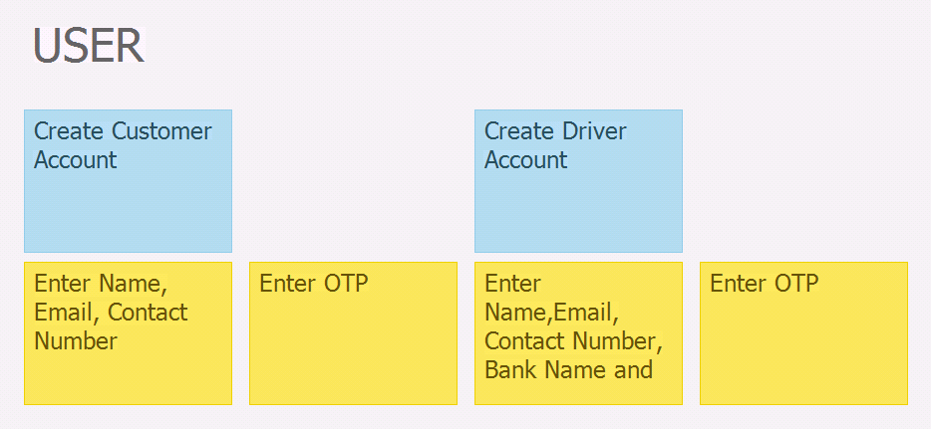

<https://daojun.storiesonboard.com/m/driver>

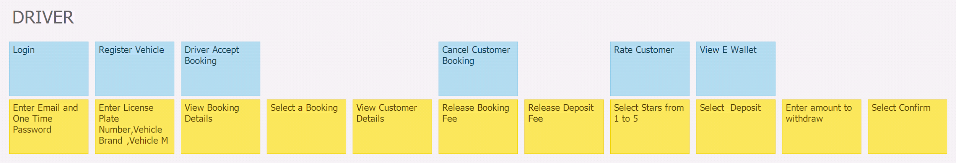

<https://daojun.storiesonboard.com/m/admin>

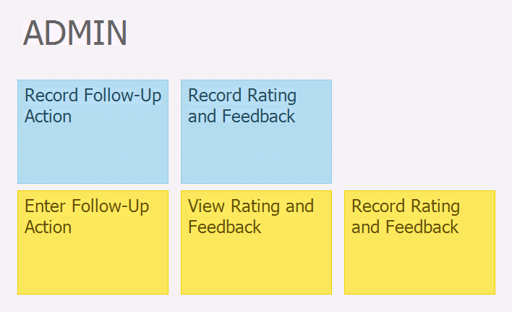

# Use Case Model

## Use Case Diagram

## 

## Brief Use Case Descriptions

### Login

This use case allows drivers and customers to login to their PickUpNow account. This is provided that the customer/driver has an existing account already. The system will display a login page that prompts the user to enter in their account details. The system will then verify the information that was entered and log the user in.

Student Name:Fong Kai Liang

Student ID: S10196491

### View ride history(customer)

This use case allows the customer and drivers to view their past rides in the past month (This is an implementation). This is provided that the customer has taken rides in the past month. The system will display all of the rides the customer has taken in the previous month, allowing the user to see the ride details including : reference number, driver and customer identification number and name, fare, pick-up point, destination, distance, date, start time and end time of the ride.

Student Name:Fong Kai Liang

Student ID: S10196491

### View ride history(driver)

This use case allows the driver to view their past rides in the past 6 months (This is an implementation). This is provided that the driver has provided ride services in the past 6 months. The system will display all the rides the driver has provided in the past 6 months, allowing the driver to see the ride details including: reference number, driver and customer identification number and name, fare, pick-up point, destination, distance, date, start time and end time of the ride.

Student Name:Fong Kai Liang

Student ID: S10196491

### Create Customer Account

This use case allows users to create a customer account with PickUpNow. This is provided they do not already have an existing account. Users will input valid name, contact number and email address. Once validated by the system, a new account will be created and stored in the database. Afterwhich, options available for the customer will be displayed.

Student Name: Lee Sutton

Student ID: S10195583

### Book Trip

This use case allows customers to book a trip with PickUpNow Taxi Company. This is provided that the customer has an account and has no pending bookings. The Customer will input the vehicle type, number of people taking the trip, their location and destination. After which the system will match them to suitable drivers. Then, the customer will pick the driver they wish to have.

Student Name: Lee Sutton

Student ID: S10195583

### Customer Cancel Booking

This use case allows customers to cancel a booking. This is provided that the customer has an existing booking. The Customer will choose the option to cancel the booking. After which the system will return the Deposit/Booking Fee, if the booking was made for a van/bus. The status of the booking will be updated to be cancelled.

Student Name: Lee Sutton

Student ID: S10195583

### Make Payment

This use case allows the customer to make payment. The system will capture the date and time of the payment and the method of payment.

Student Name: Gerald Tan

Student ID: S10196210

* + 1. **Give Feedback**

This use case allows the customer to give feedback to their driver by rating and writing a review. This is provided the trip is completed. The system will record the number of stars and the short review.

Student Name: Gerald Tan

Student ID: S10196210

* + 1. **View Customer E-Wallet**

This use case allows the customers to view their E-Wallet provided that the customer is logged in. The system will display the amount of points and credits.

Student Name: Gerald Tan

Student ID: S10196210

### 3.2.10 Register vehicle

This use case allows the driver to register a vehicle provided that the driver does not have any pre-existing vehicles.The driver would enter the license plate number , brand , model and vehicle capacity of the vehicles.The system then records the information that had been input and registers the new vehicle.

Student Name:Lim Dao Jun

Student ID:S10195591

### 3.2.11 Create Driver Account

### This use case allows a user to create a driver account provided that there is no existing driver account under the user. The user enters his name, email address, contact number, bank name and bank account number.The system assigns him a Driver ID and creates the driver account while recording the information that had been entered.

### Student Name:Lim Dao Jun

### Student ID:S10195591

**3.2.12 Accept Customer Booking**

This use case allows a driver to accept a customer's booking. This is provided that the Driver is logged in.When the driver accepts the customer booking , the system would notify the customer.

Student Name:Lim Dao Jun

Student ID:S10195591

### 3.2.13 Driver Cancel Booking

This use case allows the Driver to cancel the current booking. This is provided that the Driver must have an existing booking currently. The Driver will select the option to cancel the booking. After which the system will return Deposit/Booking Fee, if the booking was made for a Van/Bus. The status of the booking will be updated to be cancelled.

Student Name: Anderson Loke Hou Ming

Student ID: S10195290

### 3.2.14 Rate Customer

This use case allows the Driver to rate the customer by giving them a rating. This is provided the trip is completed. The system will record the number of stars.

Student Name: Anderson Loke Hou Ming

Student ID: S10195290

### 3.2.15 View Driver E Wallet

This use case allows the Driver to view their E-Wallet provided that the Driver is logged in. The system will display the amount of credits earned, the account number of the driver and the respective bank of that account number.

Student Name: Anderson Loke Hou Ming

Student ID: S10195290

## Use Case Specifications

### Create Driver Account

Student Name:Lim Dao Jun

Student ID:S10195591K

|  |  |
| --- | --- |
| Use Case ID | UC-0001 |
| Use Case Name | Create Driver Account |
| Actors | User, Email system |
| Brief Description | This use case allows a user to create a driver account provided that there is no existing driver account under the user. The user enters his name, email address, contact number, bank name and bank account number.The system assigns him a Driver ID and creates the driver account while recording the information that had been entered. |
| Pre-Condition | None |
| Post-Condition | 1.The User is registered as a driver  2.Driver is assigned a DriverID |
| Basic Flow | 1.The use case starts when User selects register as Driver  2.System prompts for Name, email address, contact number, bank name,bank account number.  3.User enters Name, email address, contact number, bank name and bank account number.  4.System Validates entered Email Address,Contact Number and Bank Account Number does not exist  5.System send OTP (one-time-password) to email address entered  6.System Prompts for OTP  7.Driver Enters OTP  8.System Validates OTP entered is correct  9.System records information entered  10.System assigns a DriverID to driver  11.System display success message |
| Alternate Flow | **Email Exists:**  4a.1 System Displays error message  4a.2 System repeats step 2 again to allow driver to try again  **Bank account Number Exists:**  4b.1 System Displays error message  4b.2 System repeats step 2 again to allow driver to try again  **Contact Number Exists:**  4c.1 System Displays error message  4c.2 System repeats step 2 again to allow driver to try again  **Invalid OTP:**  8.1 System Displays error message  8.2 System repeats step 6 to allow driver to try again |

|  |  |  |
| --- | --- | --- |
| **Test Case ID** | : | TC-0001 |
| **Test Description** | : | User signs up for Driver Account |
| **Use Case ID** | : | UC-0001 |
| **Use Case Name** | : | Create Driver Account |
| **Pre-Condition(s)** | : | None |

|  |  |  |  |
| --- | --- | --- | --- |
| **Sequence** | **Scenario** | **Test Data** | **Expected Result** |
| 1. | User Enters valid Name,Contact Number,Email Address,Bank Name and Bank Account Number. | Name:Michael Ho    Contact Number:  94320234    Email Address:  Michael_Ho@gmail.com  Bank Name:  POSB  Bank Account Number:  1111111111111111 | System sends One Time Password to stated email  In the Bank Account Number Box, there will be 3 hyphens placed at every 4 digits.  System displays prompt for One Time Password |
| 2. | User Enters Valid One Time Password. | OTP:677899 | When entering OTP, ‘*’ will be used instead in place of each character  System directs driver to the Driver Main Menu |
| 3. | Alternate Flow 1:  User enters a valid Name,Contact Number,Bank Name and Bank Account Number but enters an Email that already exists. | Name:Michael Lim    Contact Number:  96665555  Email Address:  Michael_Ho@gmail.com  Bank Name:  POSB  Bank Account Number:  1111222233334444 | System Displays an Error Message of “Email Address Already Exists!” above the Sign Up button    System Clears value typed in the Email Address Box |
| 4. | Alternate Flow 2:  User enters a valid Name,email,Bank Name and Bank Account Number but enters a Contact Number that already exists. | Name:Michael Lim    Contact Number:  94320234  Email Address:  Michael_Lim@gmail.com  Bank Name:  POSB    Bank Account Number:  1111222233334444 | System Displays an Error Message of “Contact Number Already Exists!” above the Sign Up button    System Clears value typed in the Contact Number text box |
| 5. | Alternate Flow 3:  User enters a valid Name,email,Bank Name and Contact Number but enters a Bank Account Number that already exists | Name:Michael Lim    Contact Number:  96665555  Email Address:  Michael_Lim@gmail.com  Bank Name:  POSB  Bank Account Number:  1111111111111111 | System Displays an Error Message of “Bank Account Number Exists!” above the Sign Up button    System Clears value typed in the Bank Account Number text box |
| 6. | Alternate Flow 4:  User Enters Incorrect One Time Password | OTP:666666 | System Displays an Error Message of “OTP Entered is wrong!” above the Submit button    System Clears value typed in the OTP text box |

**User Interface**

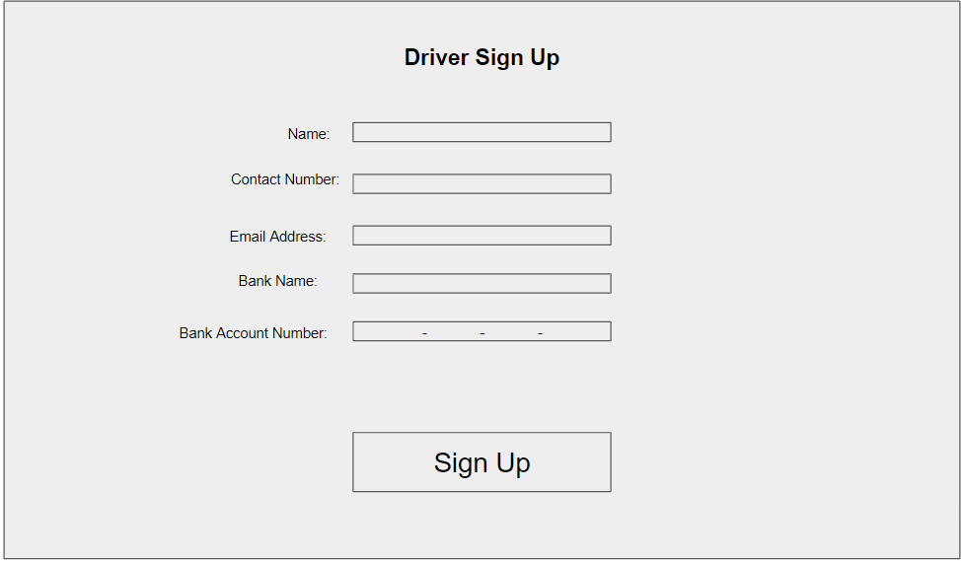

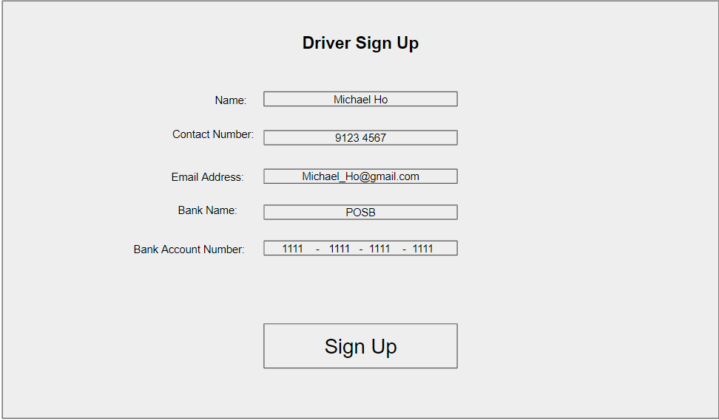

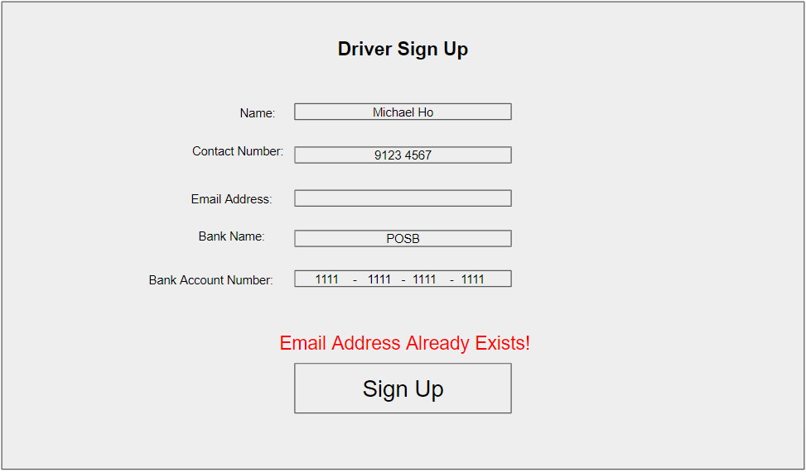

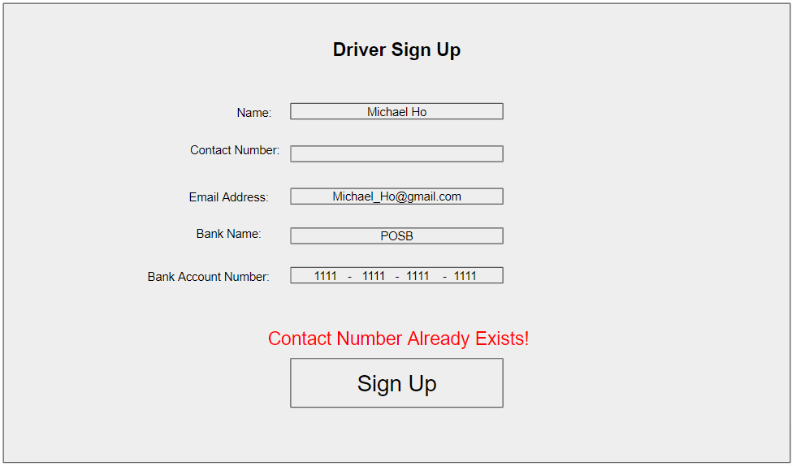

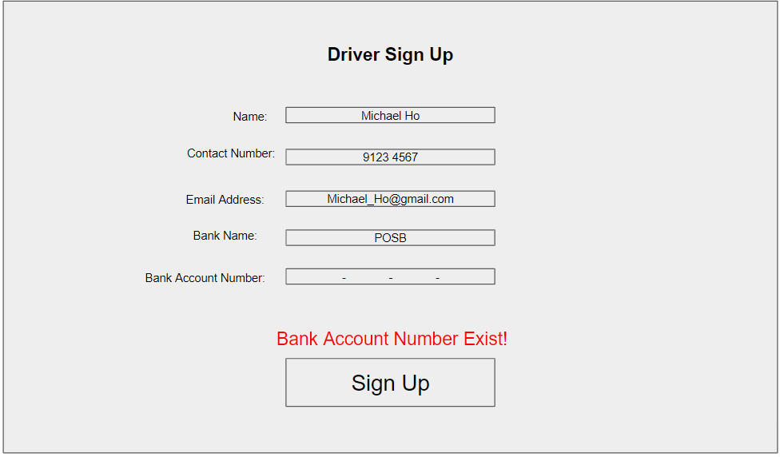

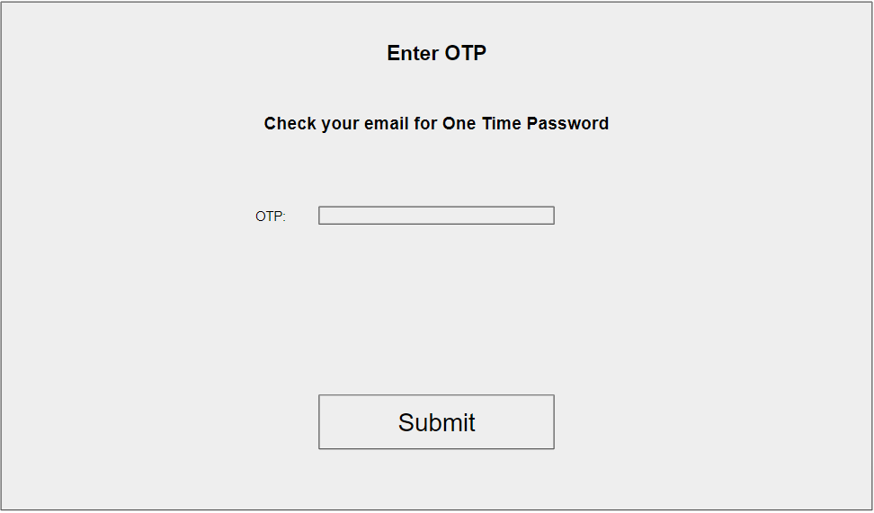

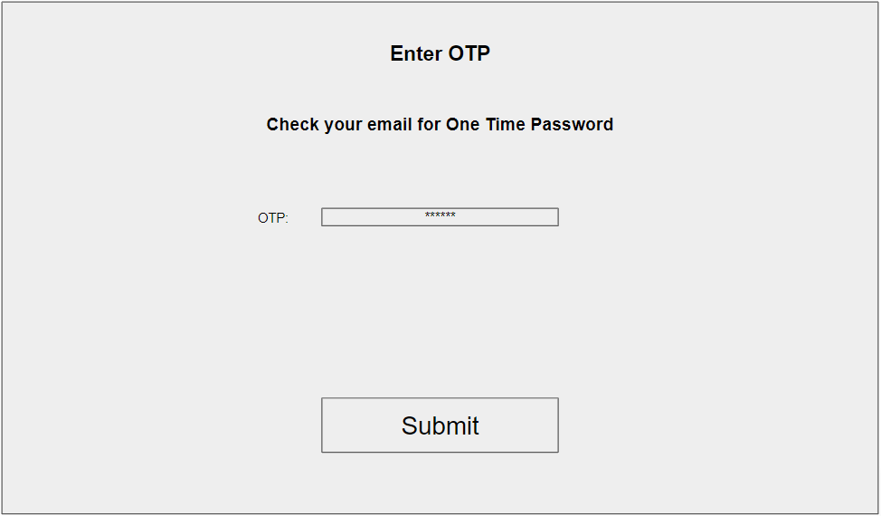

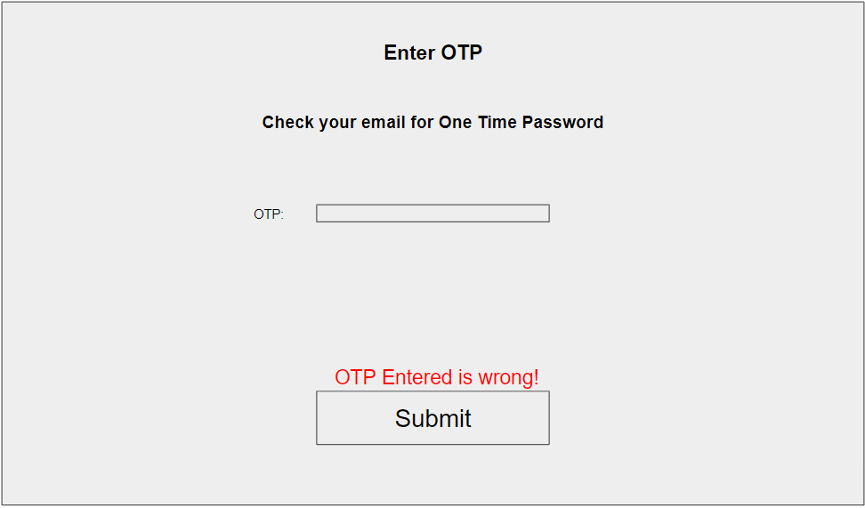

### Driver accept Customer Booking

Student Name:Lim Dao Jun

Student ID:S10195591K

|  |  |
| --- | --- |
| Use Case ID | UC-0002 |
| Use Case Name | Driver accepts customer booking |
| Actors | Driver Customer |
| Brief Description | This use case allows a driver to accept a customer's booking. This is provided that there is an existing booking from a customer under the driver. When the driver accepts the customer booking , the system will notify the customer. |
| Pre-Condition | 1.The Driver has logged in. |
| Post-Condition | 1.Customer would be informed of that the driver has accepted booking |
| Basic Flow | 1.The use case starts when driver selects Customer Booking  2. System retrieves Booking details  3.Sytem Displays Booking details  4.Driver Selects a Booking  5.System retrieves Customer details  6.System displays Customer details  7. System prompts to accept Customer’s Booking  8. Driver accepts Customer’s Booking  9. System notifies Customer  10.Use case ends |
| Alternate Flow | **Driver Has No Customer Booking:**  2.1 System display “No Booking” message  2.2 Use Case Ends  **Driver Cancel Booking:**  7.1 Driver chooses cancel booking option  7.2 Driver cancel customer booking use case executes |

|  |  |  |
| --- | --- | --- |
| **Test Case ID** | : | TC-0002 |
| **Test Description** | : |  |
| **Use Case ID** | : | UC-0002 |
| **Use Case Name** | : | Driver accepts customer booking |
| **Pre-Condition(s)** | : | Driver Must be Logged in |

|  |  |  |  |
| --- | --- | --- | --- |
| **Sequence** | **Scenario** | **Test Data** | **Expected Result** |
| 1. | Driver View Details of booking and accepts it |  | System displays list of Booking Details  System displays Customer Information of customer that make the booking  System Prompts to accept or cancel booking |
| 2. | Driver Views Details of booking and cancels it |  | System displays list of Booking Details  System displays Customer Information of customer that make the booking  System Prompts to accept or cancel booking |
| 3. | Driver Views Details of booking but has no booking under him |  | System Display “There are no Customer Bookings!” Message |

**User Interface**

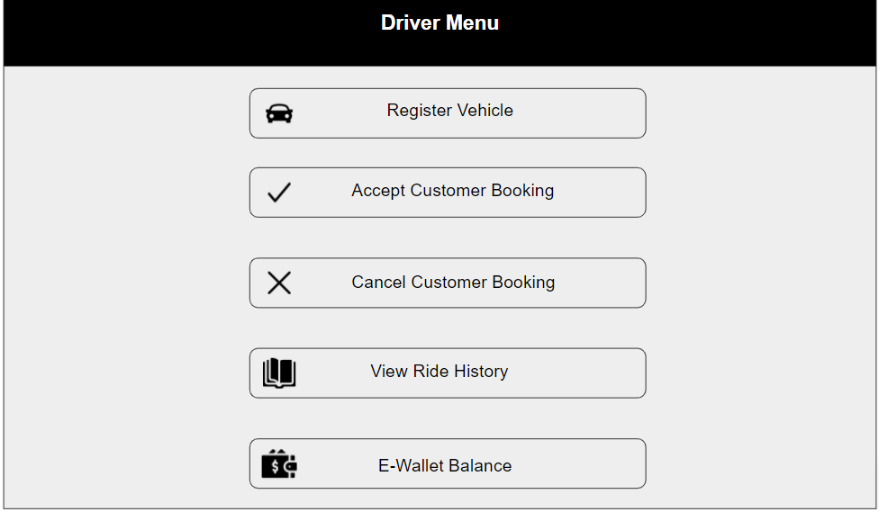

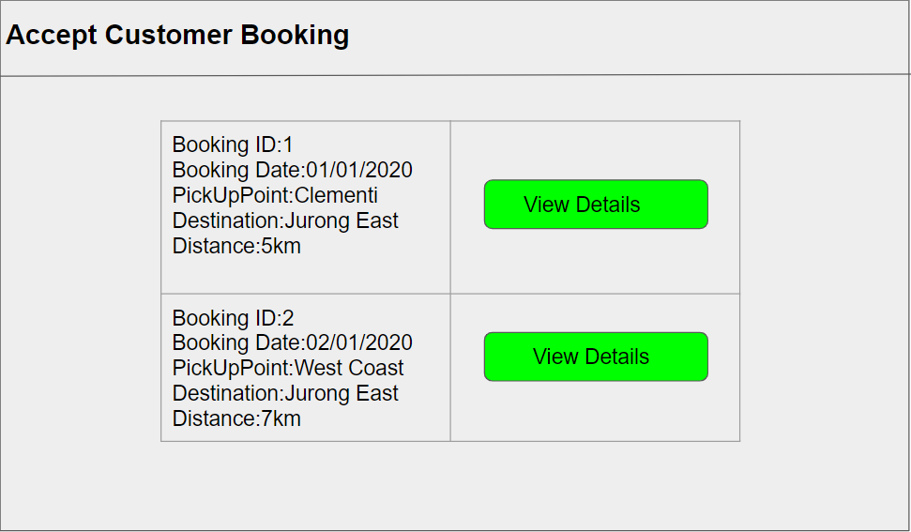

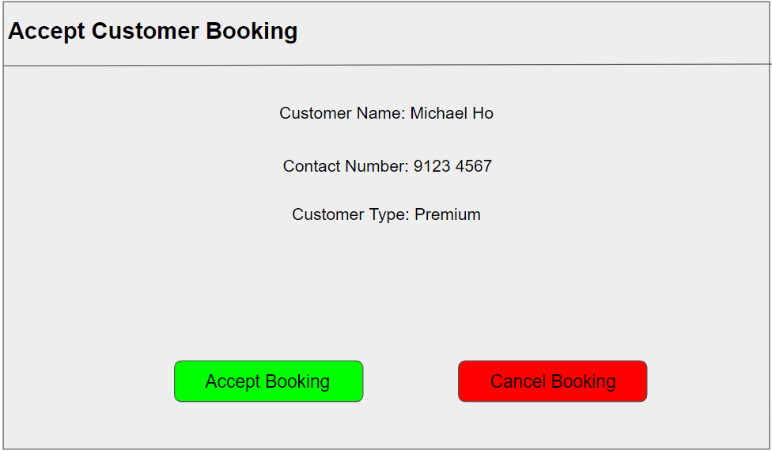

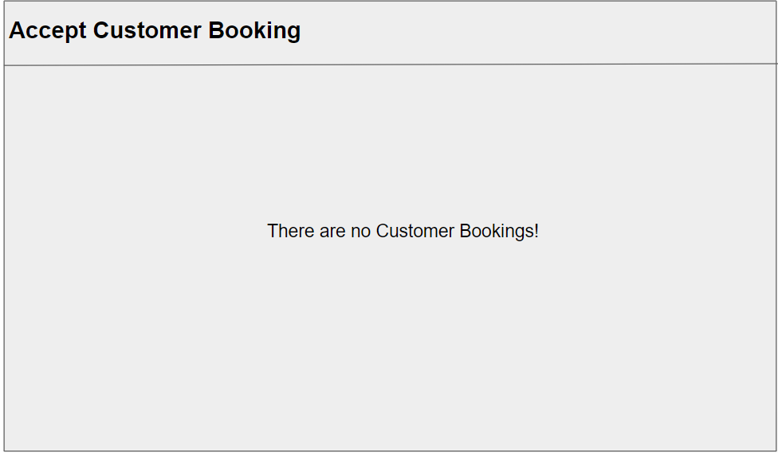

### Create Customer Account

Student Name: Lee Sutton

Student ID: S10195583E

|  |  |
| --- | --- |
| Use Case ID | UC-0003 |
| Use Case Name | Create Customer Account |
| Actors | Customer , Email System |
| Brief Description | This use case allows users to create a customer account with PickUpNow. |
| Pre-Condition | Do not already have an existing account |
| Post-Condition | System assigns CustomerID to Customer.  Options available for the customer will be displayed. |
| Basic Flow | 1. The use case starts when Users choose ‘Customer Sign Up’ 2. System prompts for Name, Contact Number, Email Address 3. User enters Name 4. User enters contact number 5. User enters email address 6. System validates the contact number and email does not exist 7. System sends OTP to email for validation 8. System prompts for OTP 9. User enters OTP 10. System validate OTP is correct 11. System assigns CustomerID to Customer 12. System records information added 13. System display Customer Menu 14. Use case ends |
| Alternate Flow | Alternate Flow 1:  Customer enters existing contact number  4.1 System displays error  4.2 System requests for customer to reenter contact number  4.3 Customer reenters not existing contact number  4.4 System proceeds to step 5  Alternate Flow 2:  Customer enters existing email  5.1 System displays error  5.2 System requests for customer to re enter email  5.3 Customer re enters not existing email  5.4 System proceeds to step 6  Alternate Flow 3:  Customer enters wrong OTP  7.1 System displays error  7.2 Goes back to step 8 |

|  |  |  |
| --- | --- | --- |
| **Test Case ID** | : | TC-0003 |
| **Test Description** | : | User signs up for customer account |
| **Use Case ID** | : | UC-0003 |
| **Use Case Name** | : | Create Customer Account |
| **Pre-Condition(s)** | : | Do not already have an existing account |

|  |  |  |  |
| --- | --- | --- | --- |
| **Sequence** | **Scenario** | **Test Data** | **Expected Result** |
| 1. | User enters name, unique contact number and unique email | Name: Gheet Shweefty  Contact number: 9345 6700  Email: ricknmorty@gmail.com | System displays OTP prompt page |
| 2. | User enters name, existing contact number and unique email | Name: Gheet Shweefty  Contact number: 9345 6789  Email: ricknmorty@gmail.com | System displays ‘Contact Number Already Exists!’  System prompts for reentering of details |
| 3. | User enters name, unique contact number and existing email | Name: Gheet Shweefty  Contact number: 9345 6700  Email: ricknmorty@gmail.com | System displays ‘Email Already Exists!’  System prompts for reentering of details |
| 4. | User enters correct OTP | OTP: 123456 | System displays customer menu |
| 5. | User enters wrong OTP | OTP: 388497 | System displays ‘OTP entered is wrong’  System prompts for OTP |

**User interface**

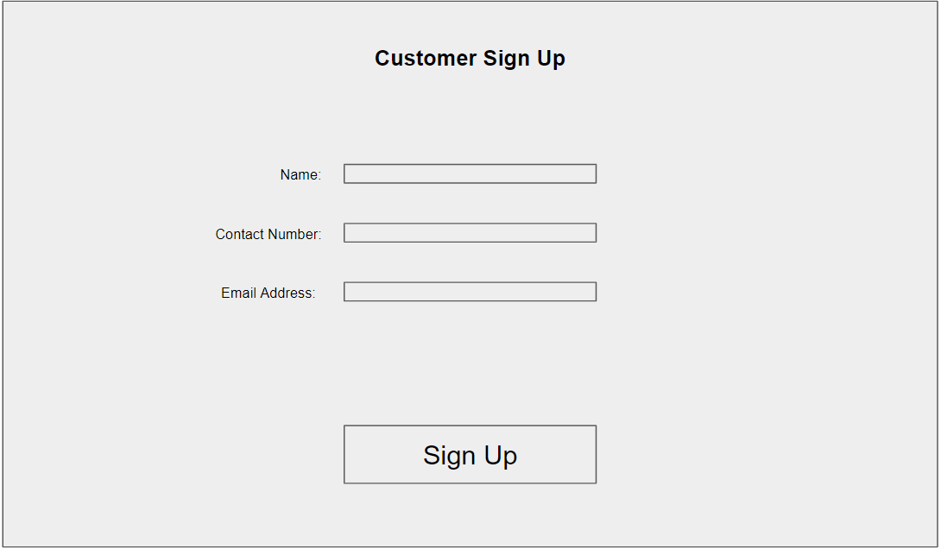

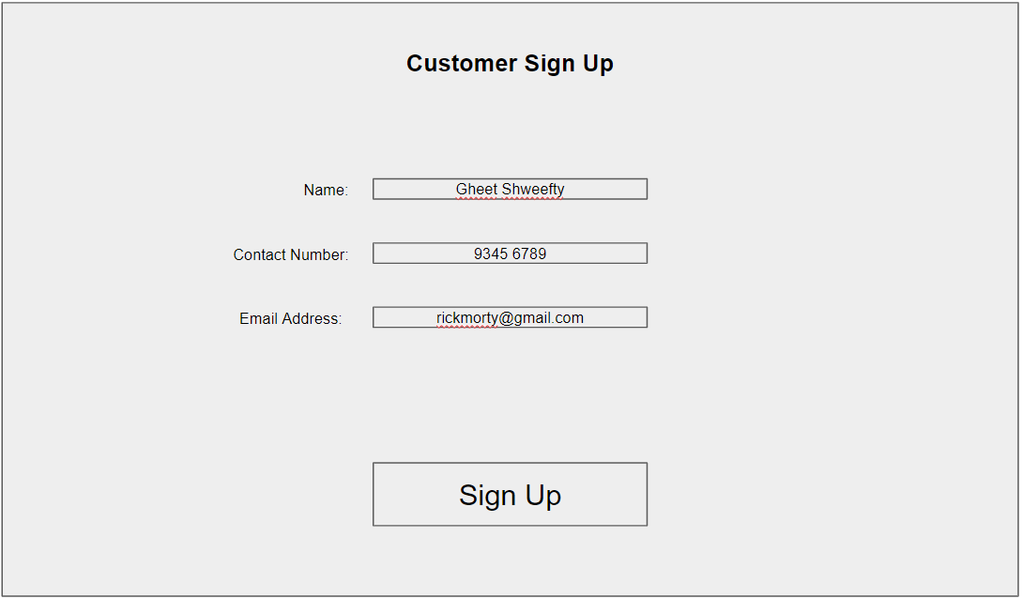

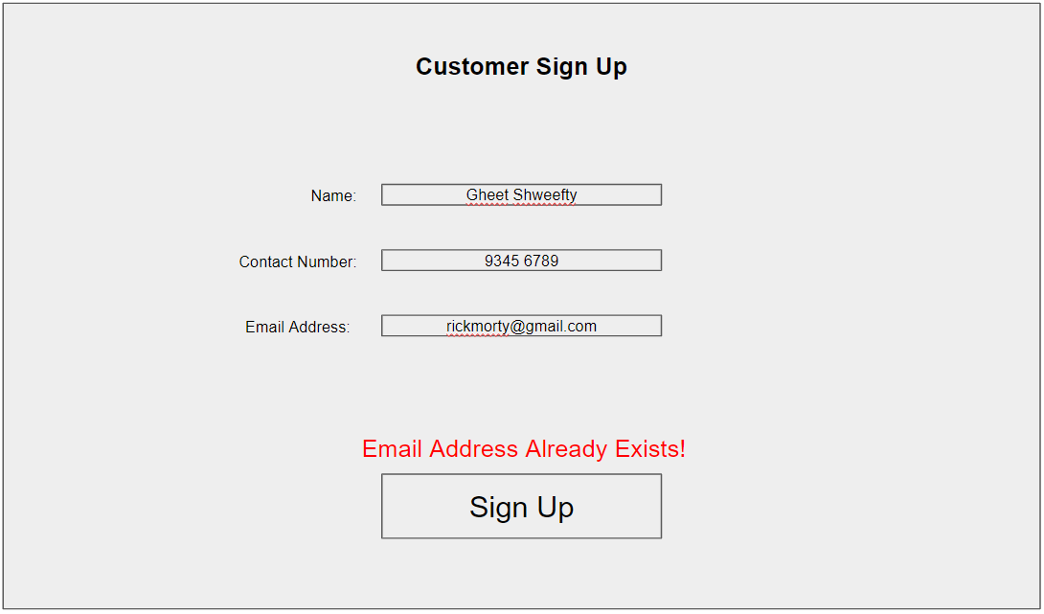

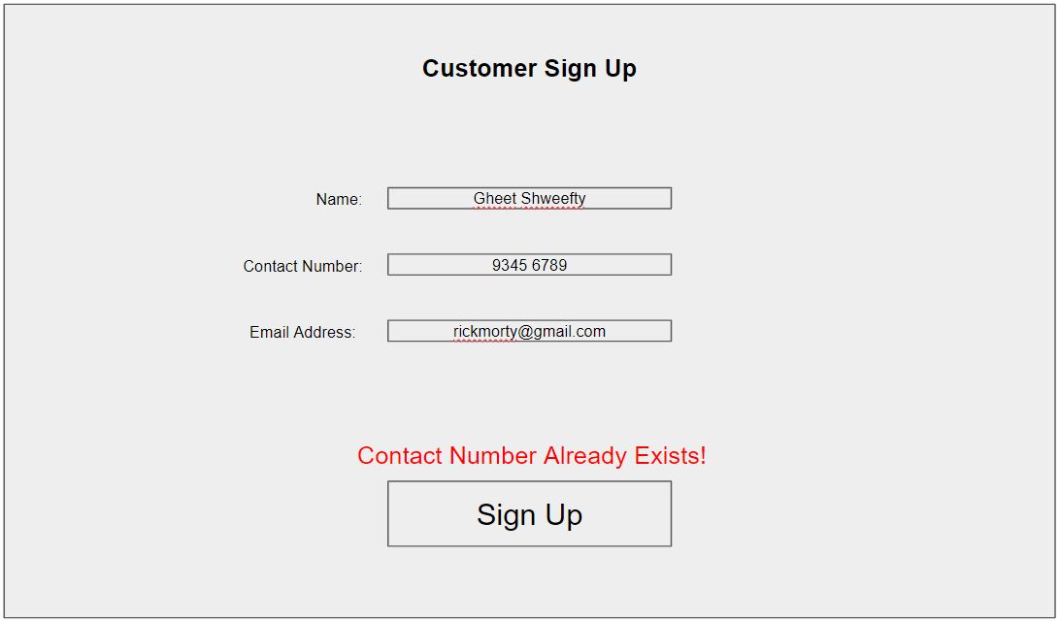

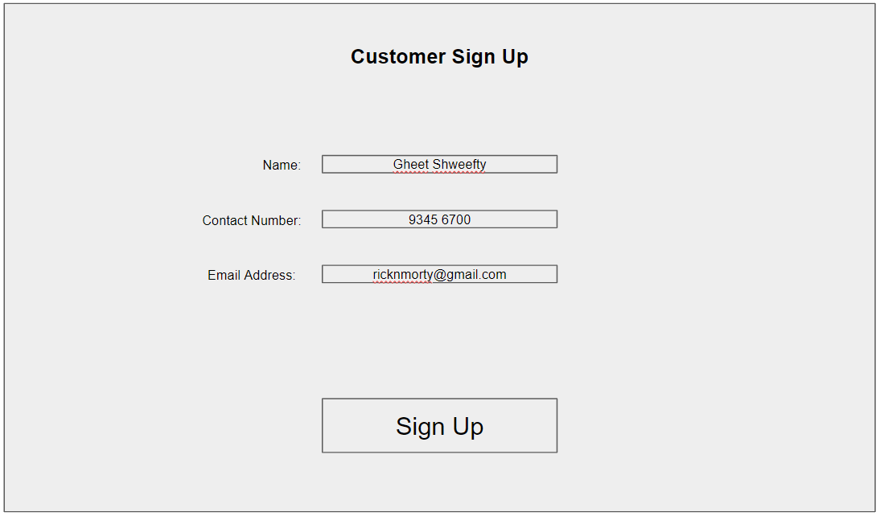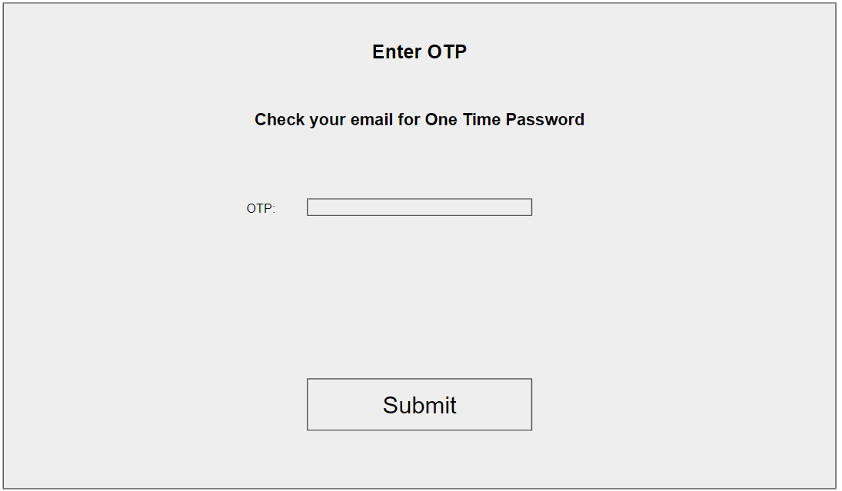

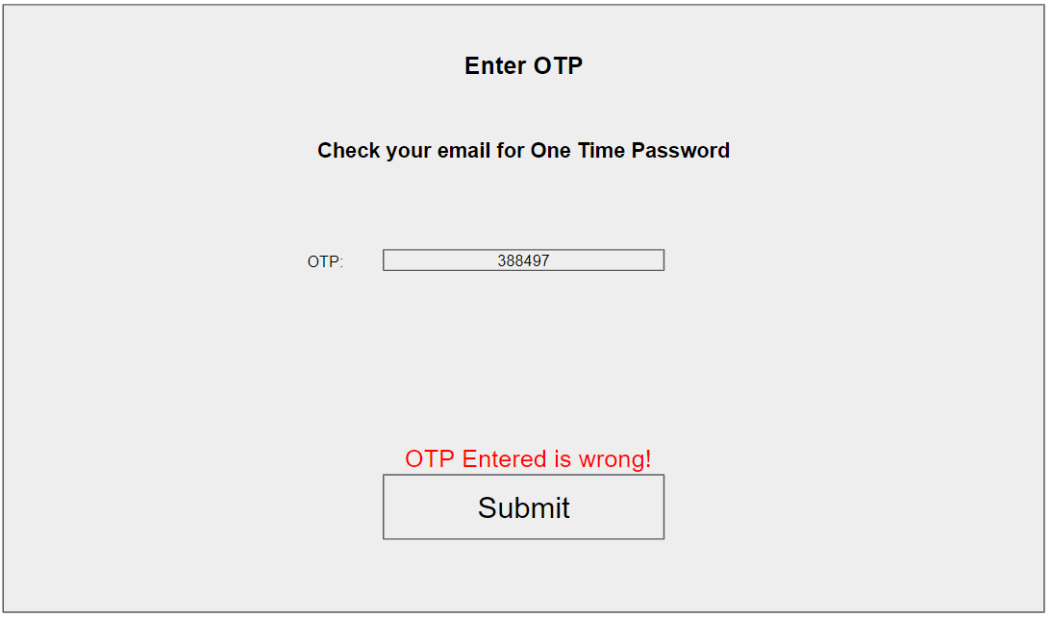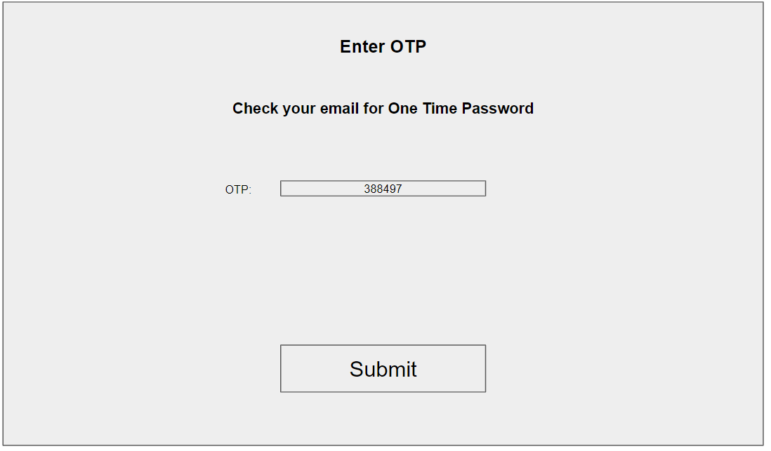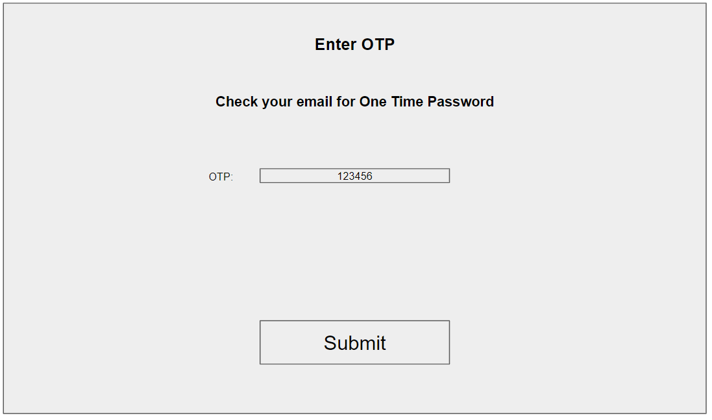

### Make Booking

Student Name: Gerald Tan

Student ID: S10196210C

|  |  |
| --- | --- |
| **Use Case ID** | UC-0004 |
| **Use Case Name** | Make Booking |
| **Brief Description** | This use case allows customers to make a booking with their preferred driver. The booking system records pickUp location, destination, booking date, date and time of trip, number of customers, distance, fare and estimated arrival time. A message will be displayed by the system upon successful booking. |
| **Actor(s)** | Customer |
| **Pre-condition(s)** | None |
| **Post-condition(s)** | Customer made a booking |
| **Basic Flow** | 1. The use case starts when the user selects “Make Booking”. 2. System gets customer details. 3. System displays a booking page. 4. Customer keys in booking Information. 5. System displays vehicles. 6. System gets vehicles. 7. System displays vehicle options. 8. Customer selects “Car”. 9. System calculates the distance,fare and estimates the arrival time. 10. System displays the distance, fare and estimated arrival time. 11. Customer selects “Book”. 12. System creates a new booking. 13. System broadcasts to nearby drivers. 14. System gets an accepted driver list. 15. System will display drivers that accept customer booking. 16. Customer selects driver. 17. System gets the driver. 18. System sends a notification to the driver. 19. System updates booking status to confirmed 20. System displays successful booking message. 21. Use case ends |
| **Alternate Flows** | Alternate Flow 1:  User select “Van”  8a.1 Customer selects “Van”.  8a.2 System calculates distance, fare, booking fee and estimates the time of arrival.  8a.3 System displays the distance, fare, estimated arrival time and booking fee.  8a.4 System proceeds to step 11.  Alternate Flow 2:  User select “ExcursionBus”  8b.1 Customer selects “ExcursionBus”  8b.2 System calculates distance, fare, deposit and estimates the arrival time.  6b.3 System displays the distance, price,estimated arrival time and deposit.  8b.4 System proceeds to step 11.  Alternate Flow 3  No Nearby Driver  15a.1 System displays no driver message  15a.2 Customer selects book again  15a.3 System returns to step 13  Alternate Flow 4  User pays for Booking fee  19a.1 System prompts user for booking fee payment  19a.2 Customer selects pay booking fee  19a.3 System sends booking fee to MakePayment use case.  19a.4System updates booking status to confirmed.  19a.5 System displays successful booking message.  19a.6 use case ends  Alternate Flow 5  User pay for deposit  19b.1 System prompts user for deposit payment  19b.2 Customer selects pay deposit  19b.3 System sends deposit amount to Make Payment use case  19b.4System updates booking status to confirmed.  19b.5 System displays successful booking message.  19b.6 Use case ends |

|  |  |  |
| --- | --- | --- |
| **Test Case ID** | : | TC0004 |
| **Test Description** | : | Customers make a booking with their preferred driver. |
| **Use Case ID** | : | UC0001 |
| **Use Case Name** | : | Make Booking |
| **Pre-Condition(s)** | : | none |

|  |  |  |  |
| --- | --- | --- | --- |
| **Sequence** | **Scenario** | **Test Data** | **Expected Result** |
| 1. | User made a car booking and accepted a driver | Pickup location: Bukit Panjang Plaza  Destination: Ngee Ann Polytechnic  Date of trip: 23/8/2020  Time of trip: 10:00am  Estimated time of arrival: 10:20am  Number of passenger: 3  Fare: 15  Distance: 10.0 | System will display Pickup location, destination, date and time of trip,number of passengers, distance, fare and estimated time of arrival.  Date is displayed in DD/MM/YYYY format.  Time is displayed in hh:mm aa format. |
| 2. | Alternate Flow 1 and 4:  User made a van booking and pay booking fee | Pickup location: Bukit Panjang Plaza  Destination: Ngee Ann Polytechnic  Date of trip: 23/8/2020  Time of trip: 10:00am  Estimated time of arrival: 10:20am  Number of passenger: 3  Fare: 20  Distance: 10.0  Booking fee: 5 | System will display distance, fare, estimated time of arrival and booking fee.  Date is displayed in DD/MM/YYYY format.  Time is displayed in hh:mm aa format. |
| 3. | Alternate Flow 2 and 5:  User made an excursion bus booking and pay deposit | Pickup location: Bukit Panjang Plaza  Destination: Ngee Ann Polytechnic  Date of trip: 23/8/2020  Time of trip: 10:00am  Estimated time of arrival: 10:20am  Number of passenger: 3  Fare: 30  Distance: 10.0  deposit: 10 | System will display Pickup location, destination, date and time of trip,number of passengers, distance, fare, estimated time of arrival and deposit.  Date is displayed in DD/MM/YYYY format.  Time is displayed in hh:mm aa format. |
| 4 | Alternate Flow 3:  User make booking but no nearby driver | Booking Information | System display message dialog - “No nearby driver” with’“book again’ button |

**User Interface Prototype**

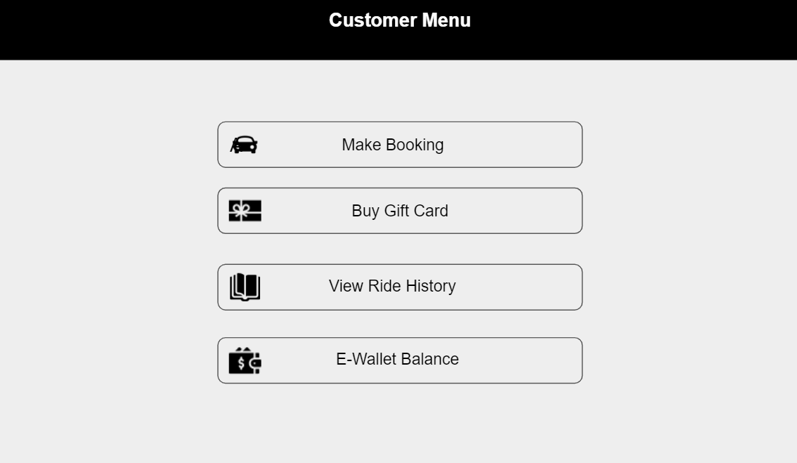

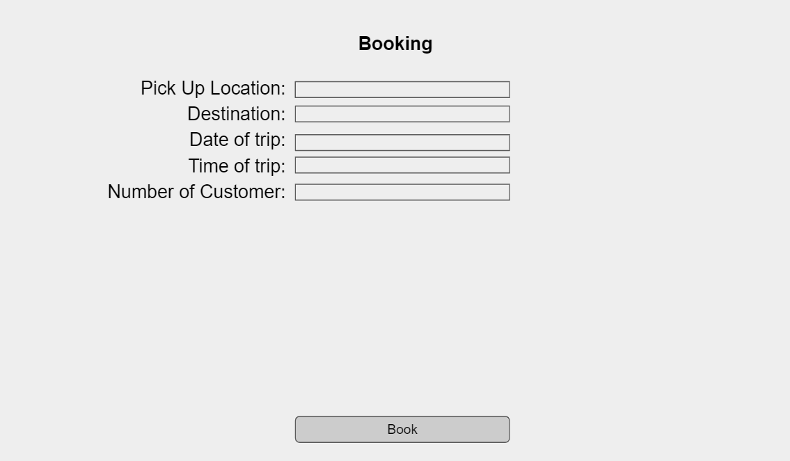

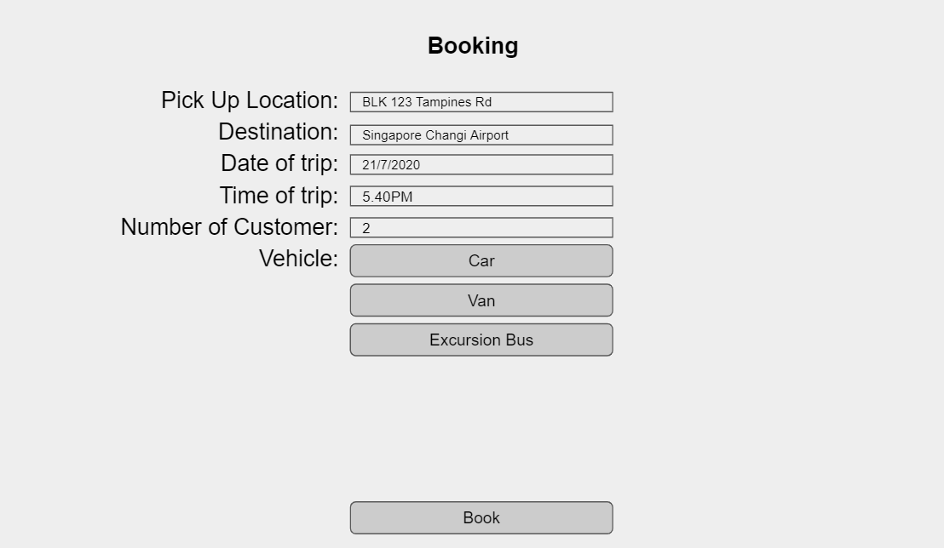

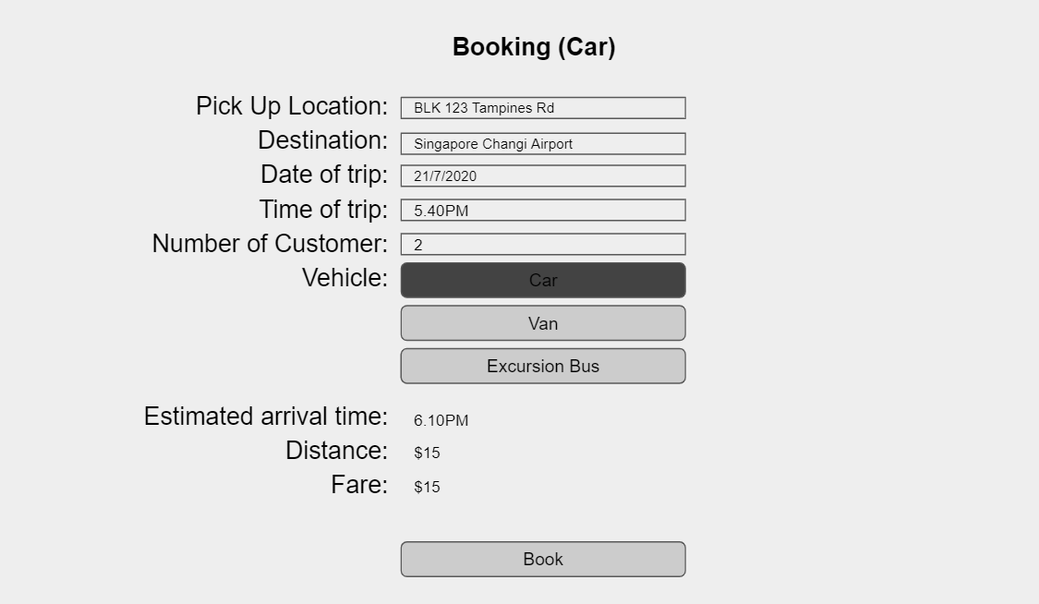

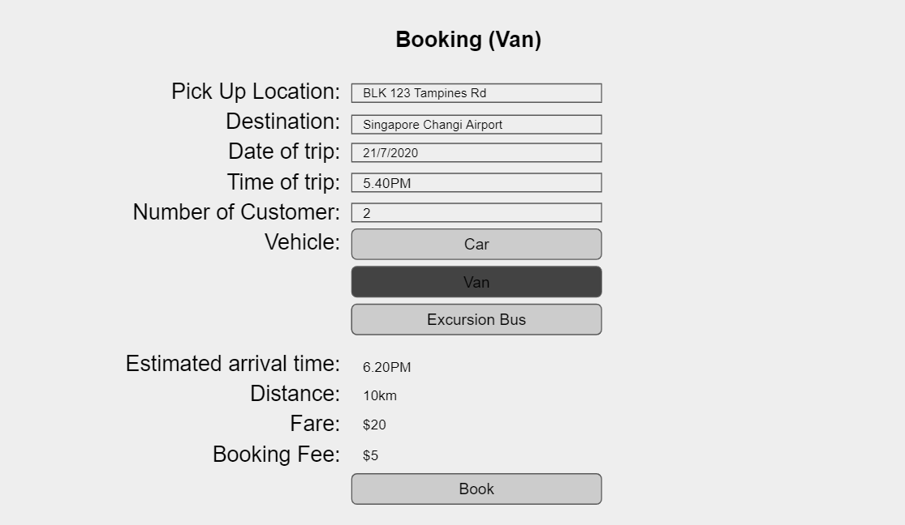

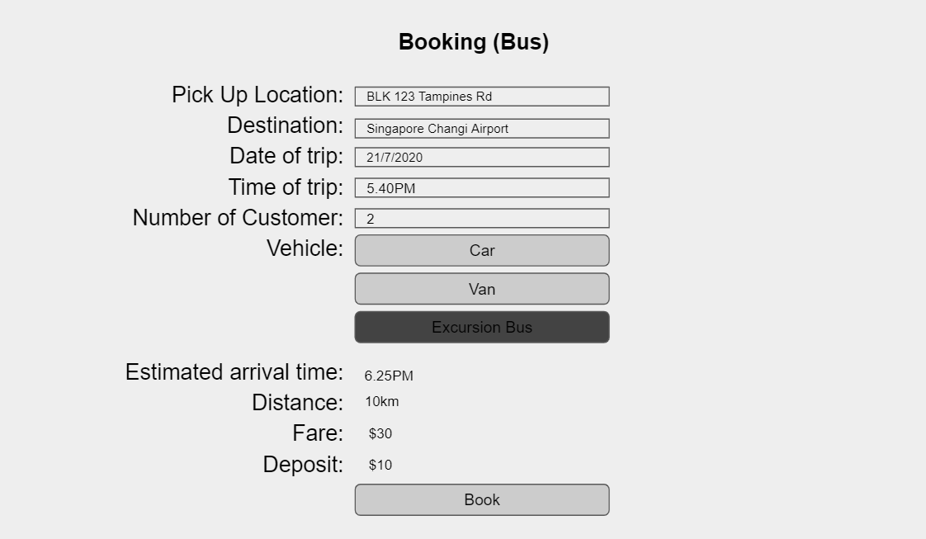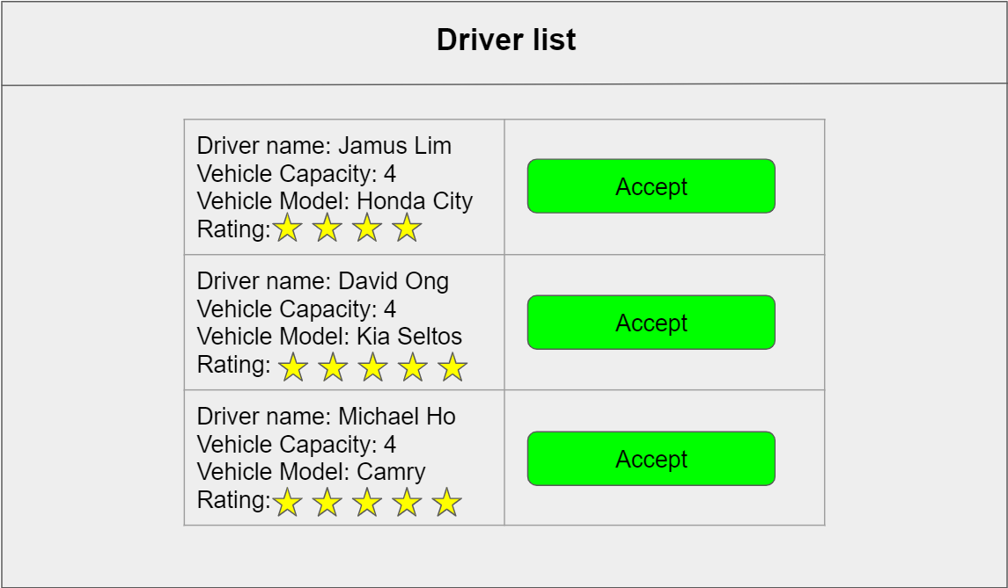

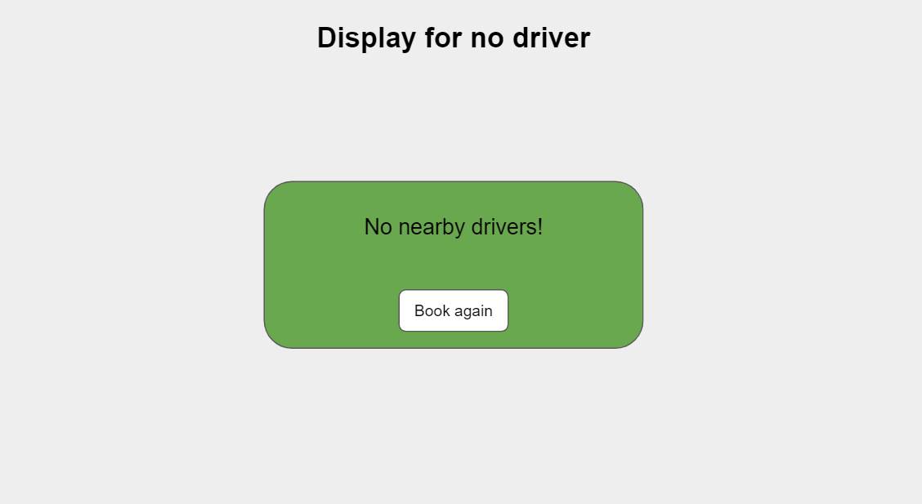

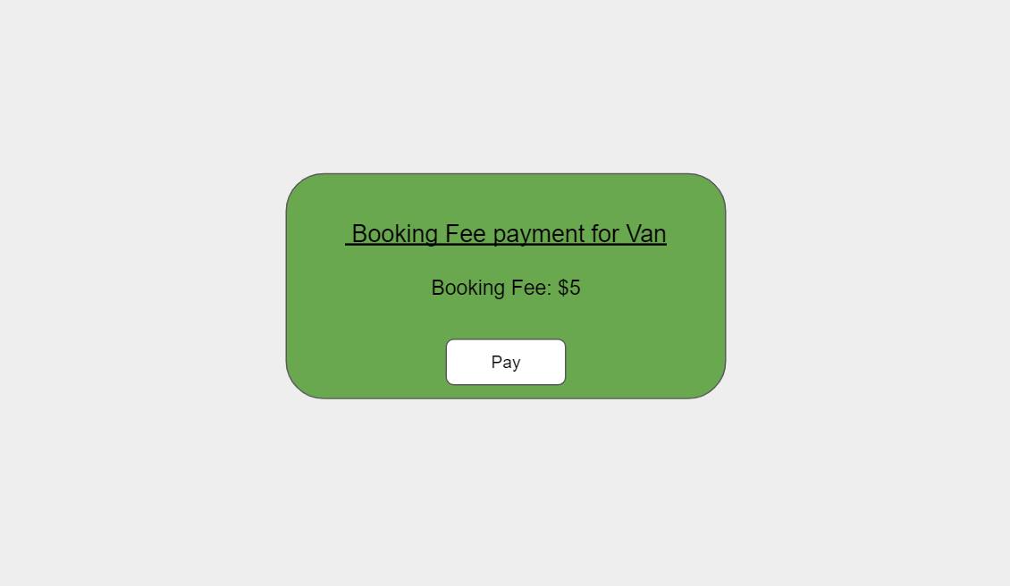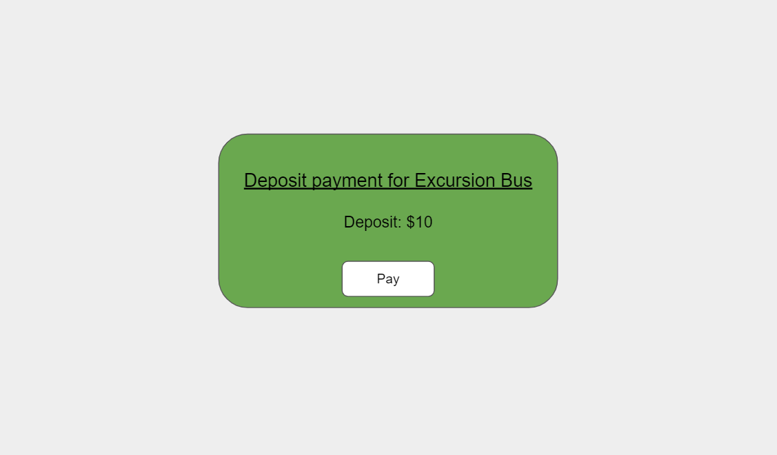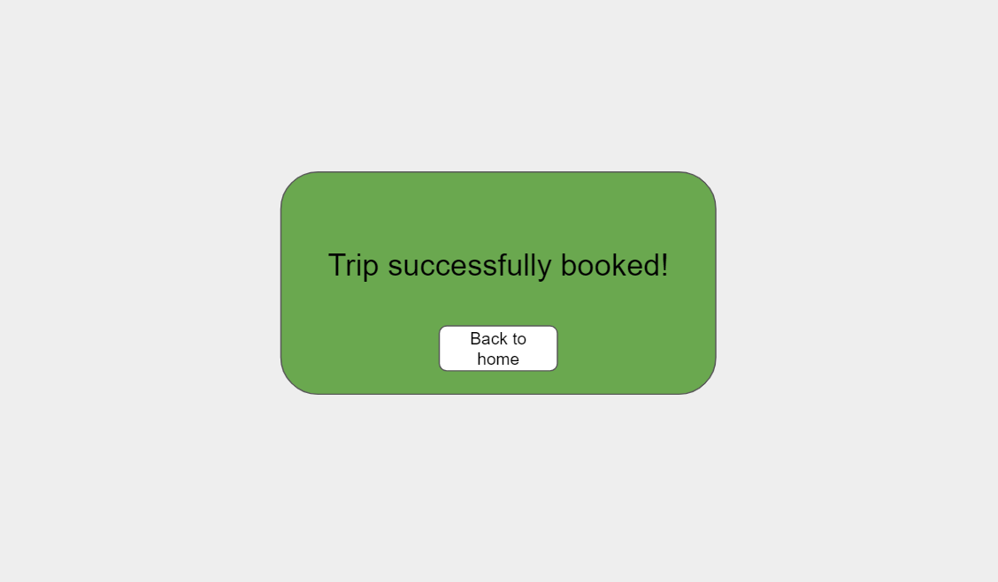

### Make Payment

|  |  |
| --- | --- |
| Use Case ID | UC-0005 |
| Use Case Name | Make Payment |
| Actors | Users |
| Brief Description | This use case allows users to make payment for their ride. |
| Pre-Condition | User must have booked a ride  User must be logged in |
| Post-Condition | System makes payment for users booking  Successful payment screen displayed |
| Basic Flow | 1. This use case starts when the user selects the "Make Payment" option  2. System displays ride details and the total cost of the ride.  3. System prompts for payment method(Gift Card, Points or Credit Card)  4. User selects Credit Card  5. System prompts user to enter Credit Card details  6. User enters credit card details  7. System prompts user for confirmation of payment  8. User confirms payment  9. System sends credit card details to Credit Card System.  10. Credit Card System validates card details  11. System displays "Successful payment"  12. The use case ends |
| Alternate Flow | Alternate flows   1. User selects gift card payment method   4. User selects pay by Gift Card  4.1 System prompts user to enter Gift Card Code  4.2 User enters Gift Card Code  4.3 System prompts confirmation  4.4 User confirms details  4.5 System sends information to Gift Card System  4.6 Gift Card System validates details  4.7 System proceeds to step 11   1. User selects points payment method   4. User selects pay by Points  4.1 System checks Users Points System if user has enough points to pay for the ride  4.2 Points System validates user details  4.3 System prompts user to confirm payment through points  4.4 User confirms payment  4.5 System proceeds to step 11   1. User’s gift card does not have enough money to pay ride   4. User selects pay by Gift Card  4.1 System prompts user to enter Gift Card Code  4.2 User enters Gift Card Code  4.3 System prompts confirmation  4.4 User confirms details  4.5 System sends information to Gift Card System  4.6 Gift Card System validates details  4.7 System displays insufficient amount  4.8 System prompts user to pay remainder by credit card  4.9 User selects pay remainder by credit card  4.10 System proceeds to step 11   1. User does not have enough points   4. User selects pay by Points  4.1 System checks Users Points System if user has points to pay for the ride  4.2 Points System validates user details  4.3 System prompts user to confirm payment through points  4.4 User confirms payment  4.5 System displays insufficient points  4.6 System prompts user to pay remainder by credit card  4.7 User selects pay remainder by credit card  4.8 System proceeds to step 11   1. Invalid Credit Card credentials   10. Credit Card is invalid  10.1 System displays "Unsuccessful payment. Please try again"  10.2 System proceeds to step 5 |

|  |  |  |
| --- | --- | --- |
| **Test Case ID** | : | TC-0005-001 |
| **Test Description** | : | User selects credit card payment method |
| **Use Case ID** | : | UC-0005 |
| **Use Case Name** | : | Make Payment |
| **Pre-Condition(s)** | : | User must be signed in to a customer account and has booked a ride |

|  |  |  |  |
| --- | --- | --- | --- |
| **Sequence** | **Scenario** | **Test Data** | **Expected Result** |
| 1. | User enters correct Credit Card Details | Enter correct card details | System will display “successful payment” message |
| 2. | Alternate Flow: User enters wrong Credit Card Details | Enter wrong credit card details | System will display “unsuccessful payment” |
|  |  |  | System will display “Please try again” |

|  |  |  |
| --- | --- | --- |
| **Test Case ID** | : | TC-0005-002 |
| **Test Description** | : | User selects gift card payment method |
| **Use Case ID** | : | UC-0005 |
| **Use Case Name** | : | Make Payment |
| **Pre-Condition(s)** | : | User must be signed in to a customer account and has booked a ride |

|  |  |  |  |
| --- | --- | --- | --- |
| **Sequence** | **Scenario** | **Test Data** | **Expected Result** |
| 1. | User enters correct Gift Card Code | Enter correct gift card code | System will display “successful payment” message |
| 2. | Alternate Flow: User enters wrong Gift Card Code | Enter wrong gift card code | System will display “unsuccessful payment” |
|  |  |  | System will display “Please try again” |
| 3. | Alternate Flow 3:  User enters correct Gift Card Code but does not have enough to pay for ride | Enter correct gift card code that has insufficient money to pay for ride | System will display “insufficient amount” |
|  |  |  | System will display “Pay remainder by credit card” |

|  |  |  |
| --- | --- | --- |
| **Test Case ID** | : | TC-0005-003 |
| **Test Description** | : | User selects points payment method |
| **Use Case ID** | : | UC-0005 |
| **Use Case Name** | : | Make Payment |
| **Pre-Condition(s)** | : | User must be signed in to a customer account and has booked a ride |

|  |  |  |  |
| --- | --- | --- | --- |
| **Sequence** | **Scenario** | **Test Data** | **Expected Result** |
| 1. | User has sufficient points to pay for ride |  | System will display “successful payment” message |
| 2. | Alternate Flow 4 : User does not have sufficient points to pay for ride |  | System will display “insufficient amount” |
|  |  |  | System will display “Pay remainder by credit card” |

User Interface

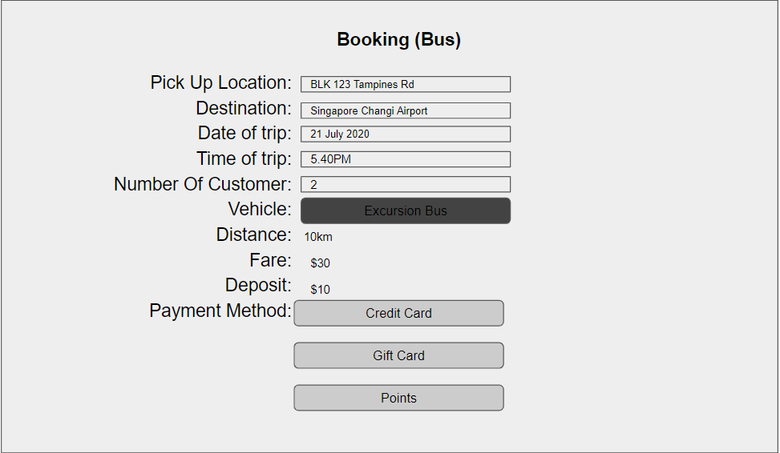

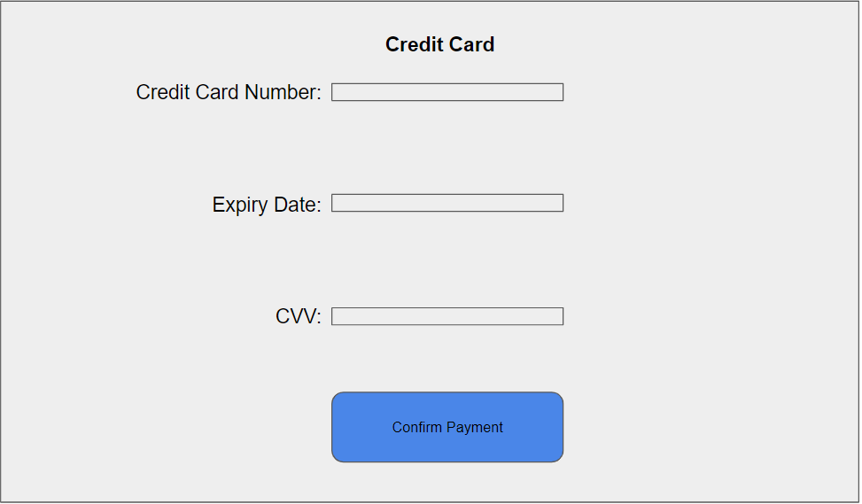

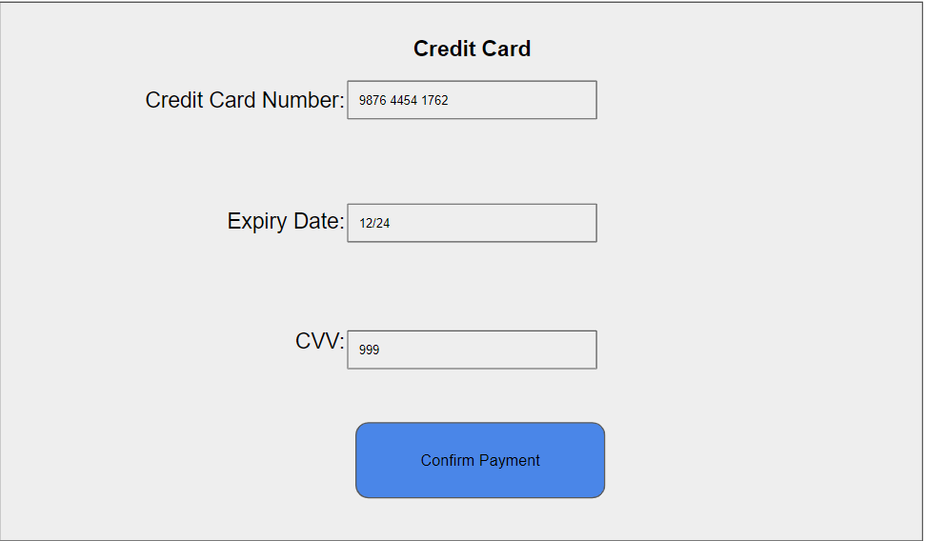

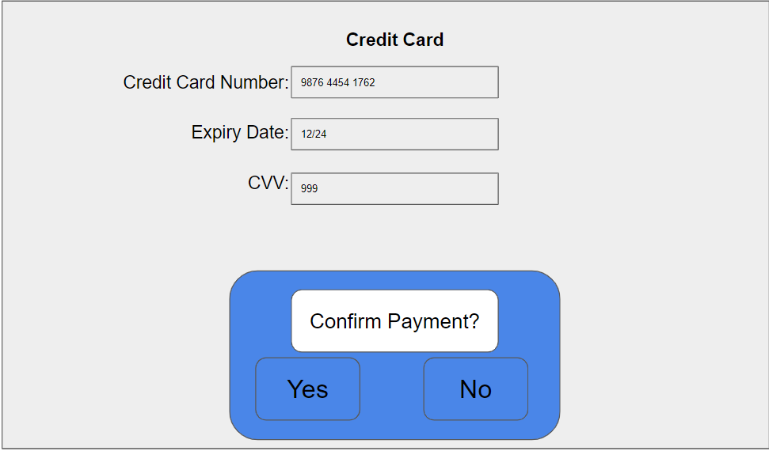

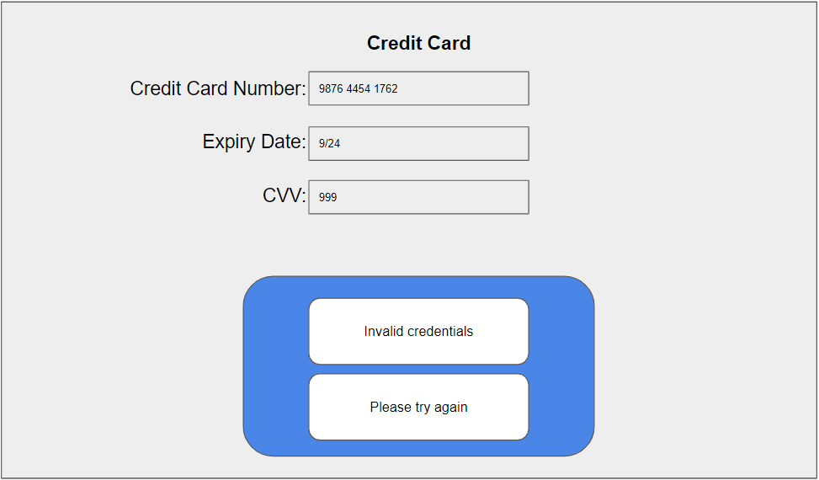

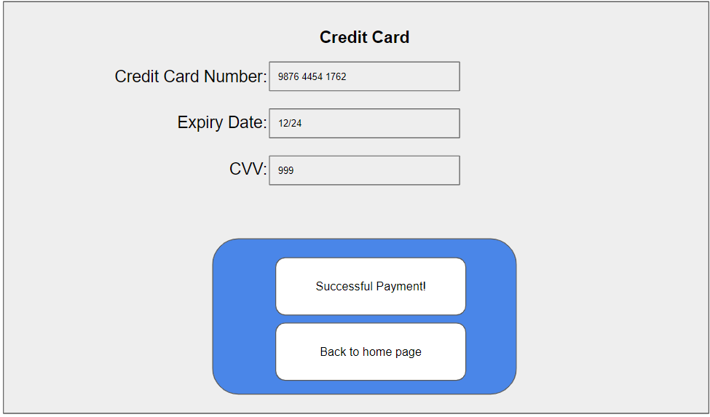

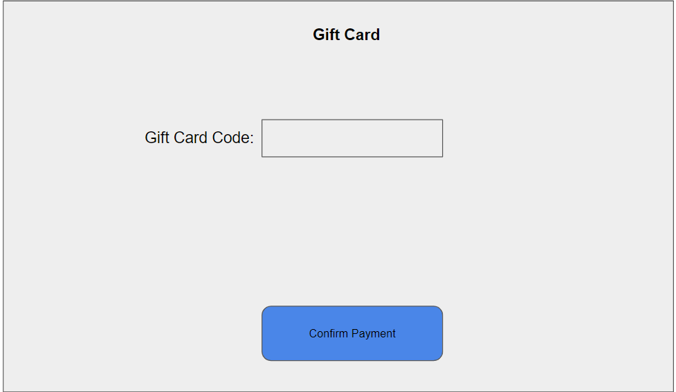

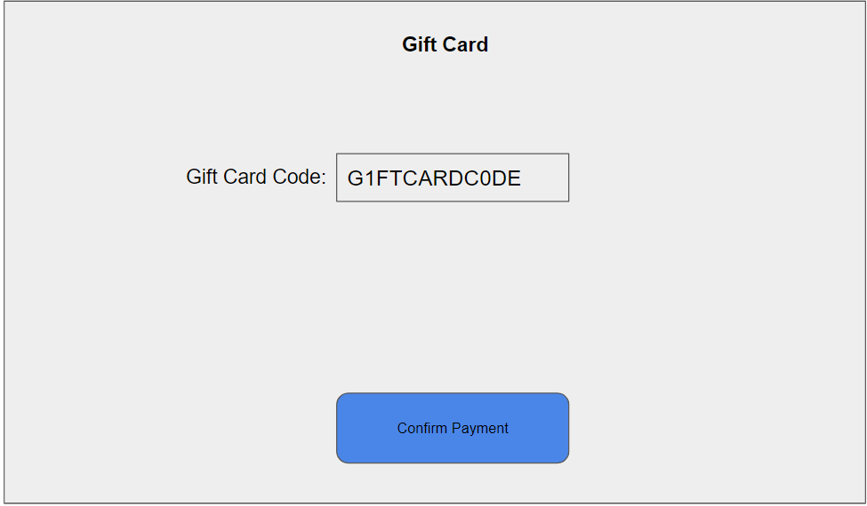

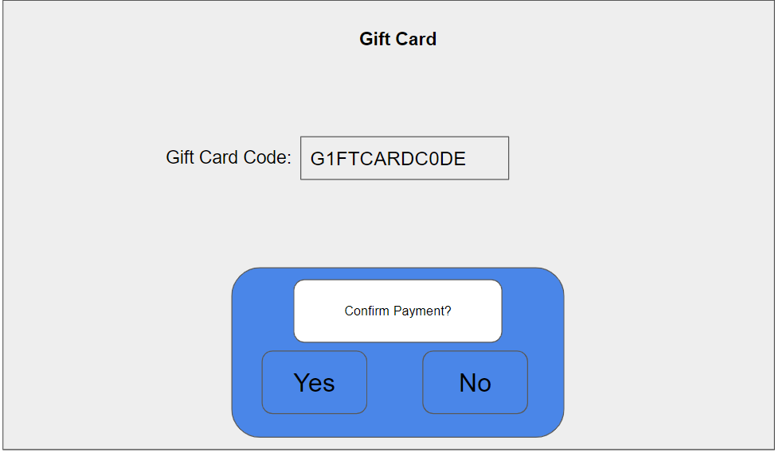

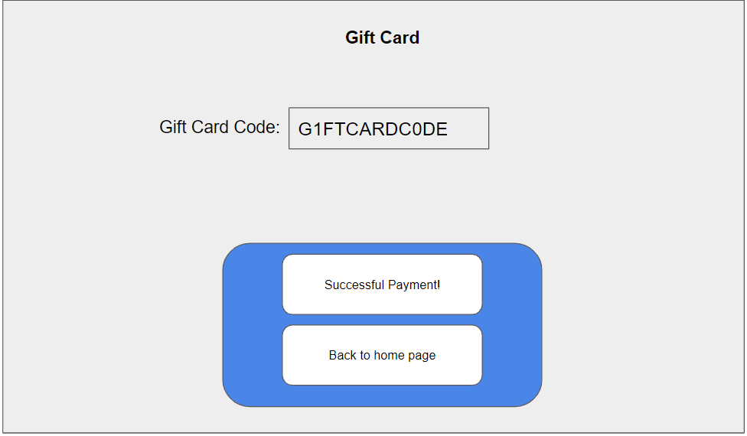

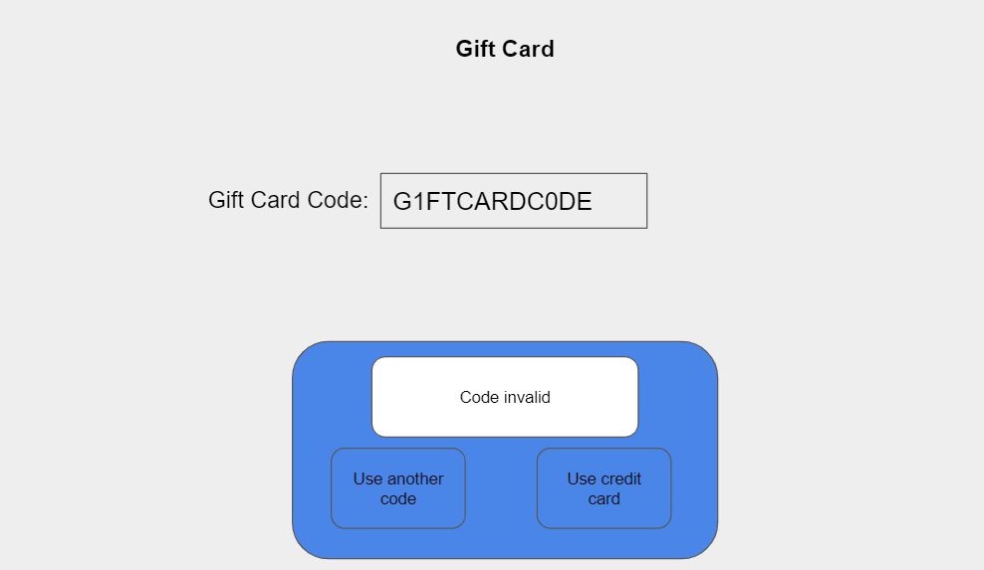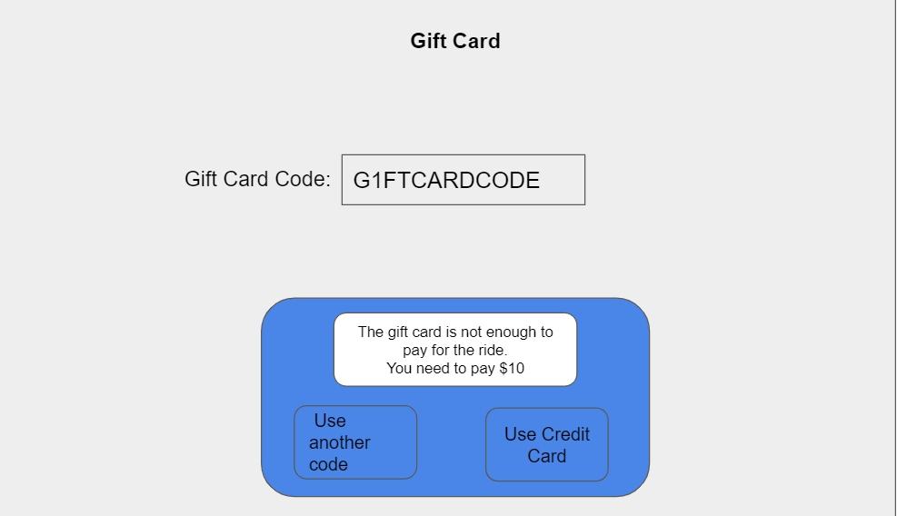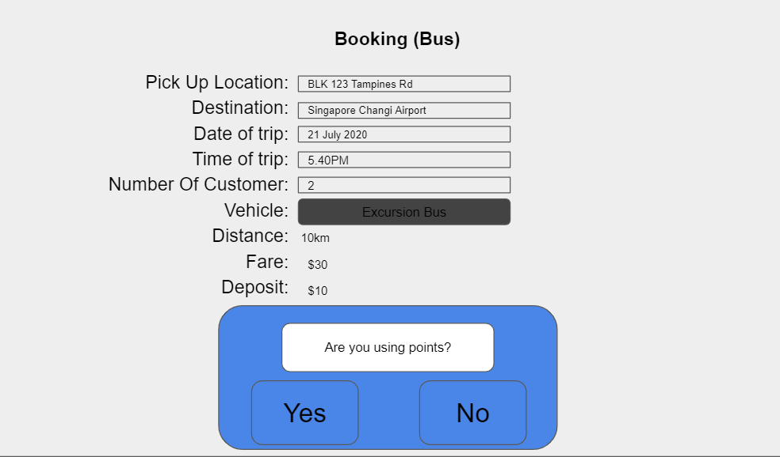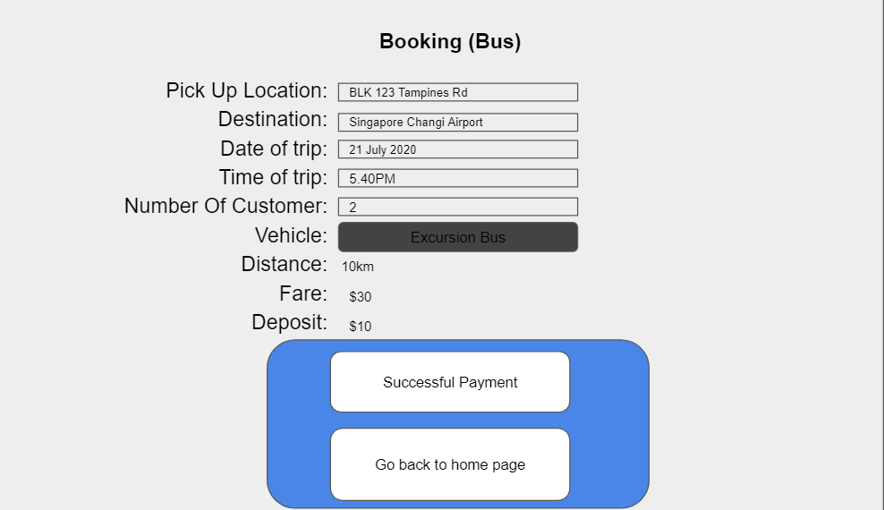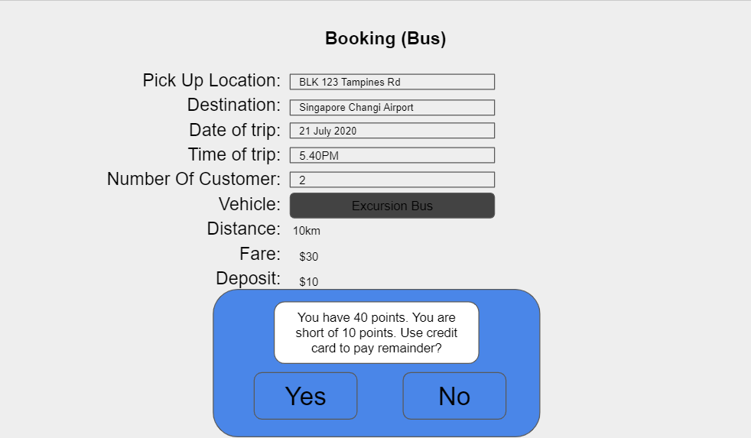

Student Name: Fong Kai Liang

Student ID: S10196491H

### Cancel Booking

Student Name: Anderson Loke Hou Ming

Student ID: S10195290H

|  |  |
| --- | --- |
| **Use Case ID** | UC-0006 |
| **Use Case Name** | Cancel Booking |
| **Brief Description** | This use case allows Customers to cancel a booking if they have a customer account and must have a pending booking. The Cancel trip system records customer location, destination, date, number of customers, distance, price and reason for cancellation. A message will be displayed by the system upon successful cancellation |
| **Actor(s)** | Customer |
| **Pre-condition(s)** | Customer must have a customer account  User must have a pending booking |
| **Post-condition(s)** | Customer made a Cancellation |
| **Basic Flow** | 1. The use case starts when user select “Cancel Booking” 2. System create a new cancellation 3. System display cancellation page 4. User input reason for cancellation details 5. User select “confirm” 6. System validates whether there is any reason for cancellation 7. System update Booking status to cancelled and the reason for callelation 8. System update Booking status to cancelled 9. System display successful Cancellation message |
| **Alternate Flows** | Alternate Flow 1:  User does not input any reason for cancellation  6.1 System display error message.  6.2 System proceeds to step 3 |

|  |  |  |
| --- | --- | --- |
| **Test Case ID** | : | TC-0006 |
| **Test Description** | : | Customer cancel the booking |
| **Use Case ID** | : | UC-0006 |
| **Use Case Name** | : | Customer Cancel Booking |
| **Pre-Condition(s)** | : | Customer must have a customer account  Customer must have a pending booking |

|  |  |  |  |
| --- | --- | --- | --- |
| **Sequence** | **Scenario** | **Test Data** | **Expected Result** |
| 1. | Customer enter reason for cancellation | The car came too slow, got another Cab coming to pick me up already | System update Booking status to cancelled and the reason for callelation  System update Booking status to cancelled  System display successful Cancellation message |
| 2. | Alternate Flow 1:  User does not input any reason for cancellation. |  | System display error message.  System prompts for reasons |

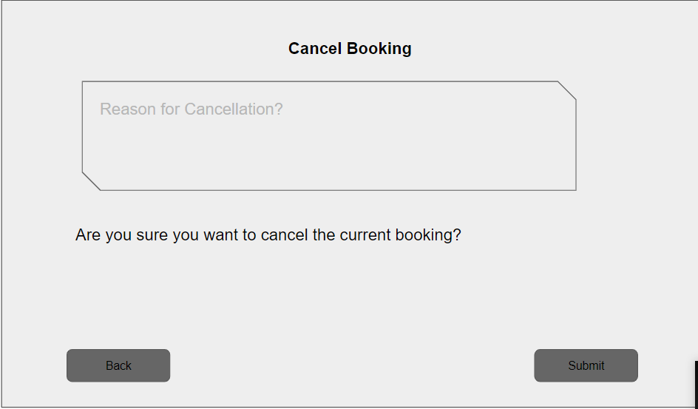

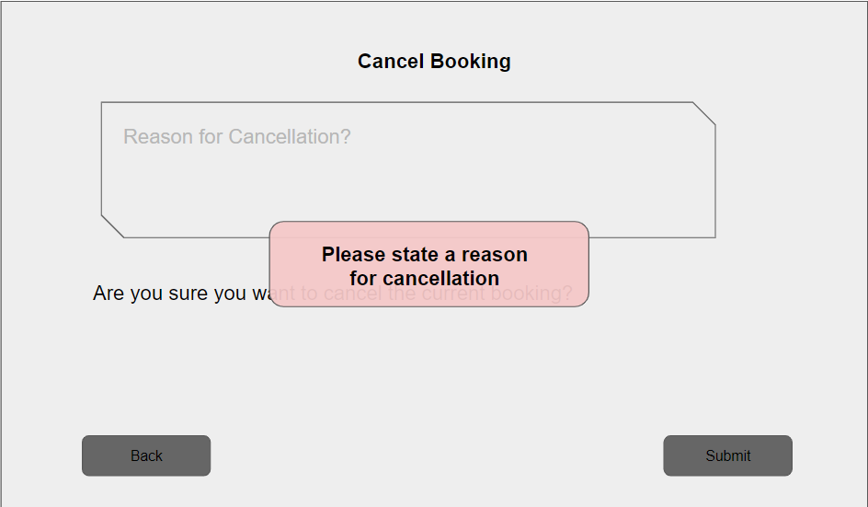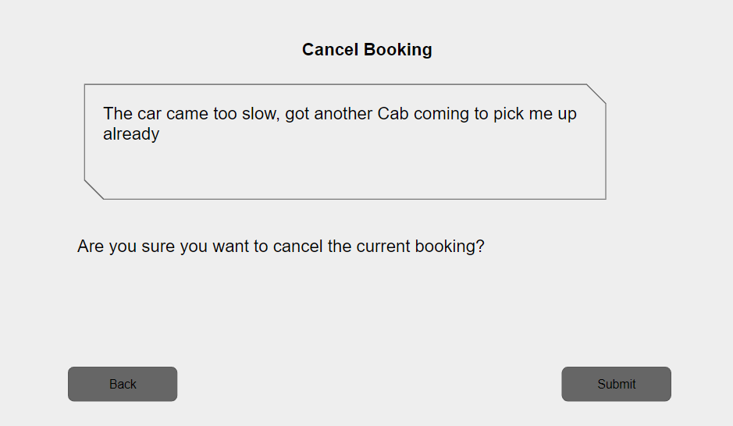

### Driver E-Wallet

Student Name: Anderson Loke Hou Ming

Student ID: S10195290H

|  |  |
| --- | --- |
| **Use Case ID** | UC-0007 |
| **Use Case Name** | Driver E-Wallet |
| **Brief Description** | This use case allows Drivers to view earnings from their trips if they have a driver account. The Driver E-waller system records driver details, date, time, credit earned and payment method. A message will be displayed by the system upon successful transaction |
| **Actor(s)** | Driver |
| **Pre-condition(s)** | Driver must have a driver account |
| **Post-condition(s)** | None |
| **Basic Flow** | 1. The use case starts when driver choose ‘View E-wallet’ 2. System display View E-wallet page 3. User select “Withdraw” 4. System calculate and display the total earnings 5. Driver input amount to withdraw 6. Driver select “confirm” 7. System update Credits to after the withdrawn balance 8. System communicates with bank to send earnings 9. System display successful deposit message |
| **Alternate Flows** | Alternate Flow 1:  Driver selects “View Statement”  3.1 Driver select “View Statement”  3.2 System calculate and display the total earnings and daily Earnings  Alternate Flow 2:  Driver does not have sufficient earnings  5.1 Driver input amount higher than earnings  5.2 Driver select “Withdraw earnings’  5.3 System display unsuccessful deposit message |

|  |  |  |
| --- | --- | --- |
| **Test Case ID** | : | TC-0007 |
| **Test Description** | : | Driver view E-wallet |
| **Use Case ID** | : | UC-0007 |
| **Use Case Name** | : | Driver E-Wallet |
| **Pre-Condition(s)** | : | Driver must have a driver account |

|  |  |  |  |
| --- | --- | --- | --- |
| **Sequence** | **Scenario** | **Test Data** | **Expected Result** |
| 1. | Drivers select withdraw |  | System calculate and display the total earnings |
| 2. | Driver input amount to withdraw | Amount : 1028 | System update Credits to after the withdrawn balance  System communicates with bank to send earnings  System display successful deposit message |
| 3. | Alternative Flow 1:  Driver enters View statement |  | System calculate and display the total earnings and daily Earnings |
| 4. | Alternate Flow 2:  Driver does not have sufficient earnings |  | System displays ‘OTP entered is wrong’  System prompts for OTP |
| 5. | Driver input amount higher than earnings | Amount: 2000 | System display unsuccessful deposit message |

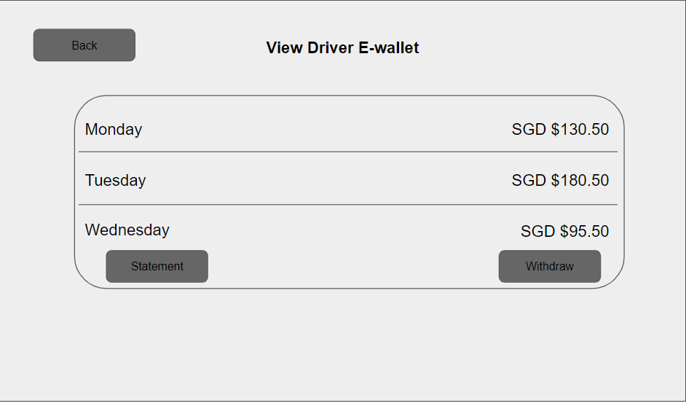

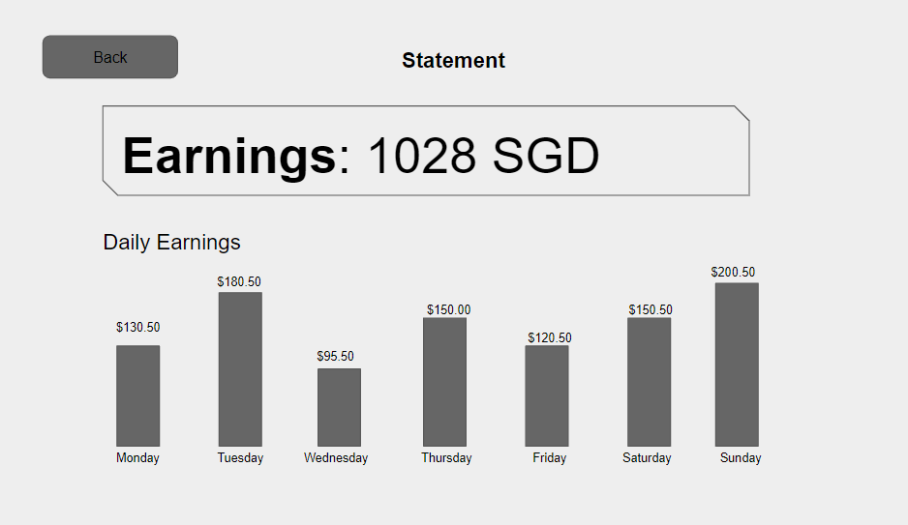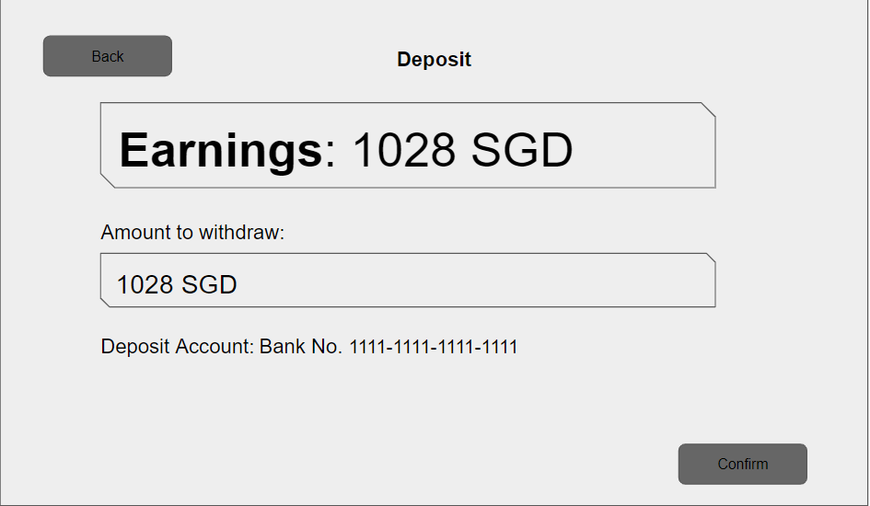

# 

# 

# 

# Class Diagram

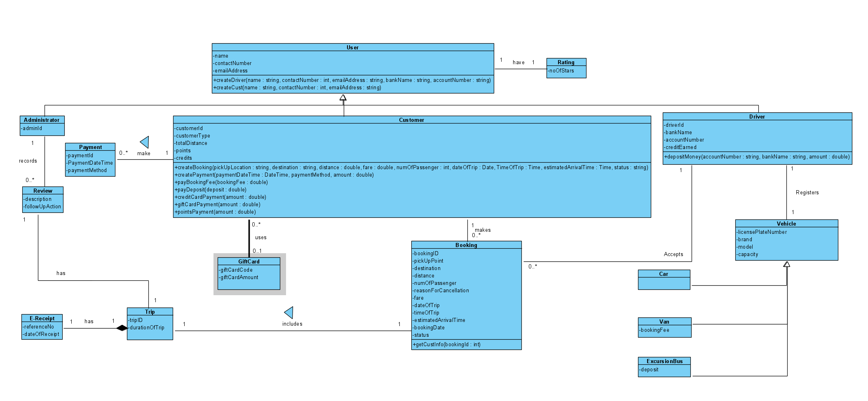

Administrator, Payment,review,Trip and E-Receipt Class

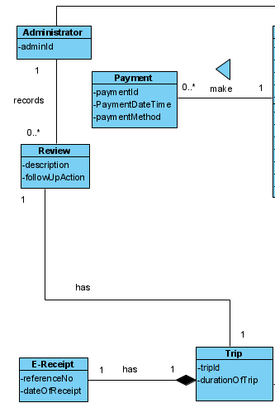

User and Rating Class

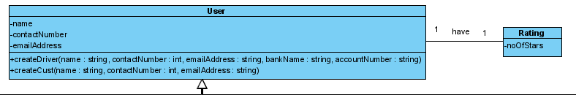

Customer Class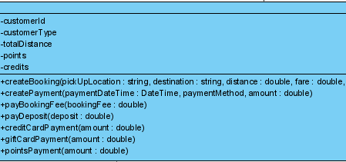

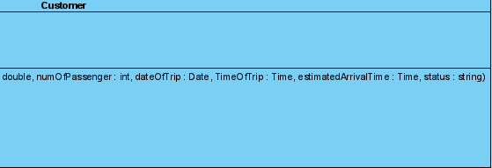

GiftCard and Booking Class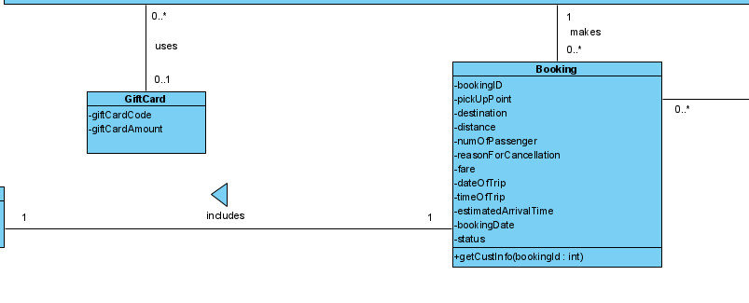Driver,Vehicle,Car,Van and ExcursionBus Class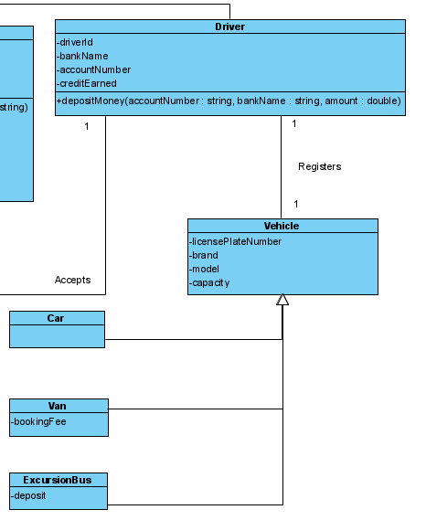

# Sequence Diagrams

## Create Driver Account

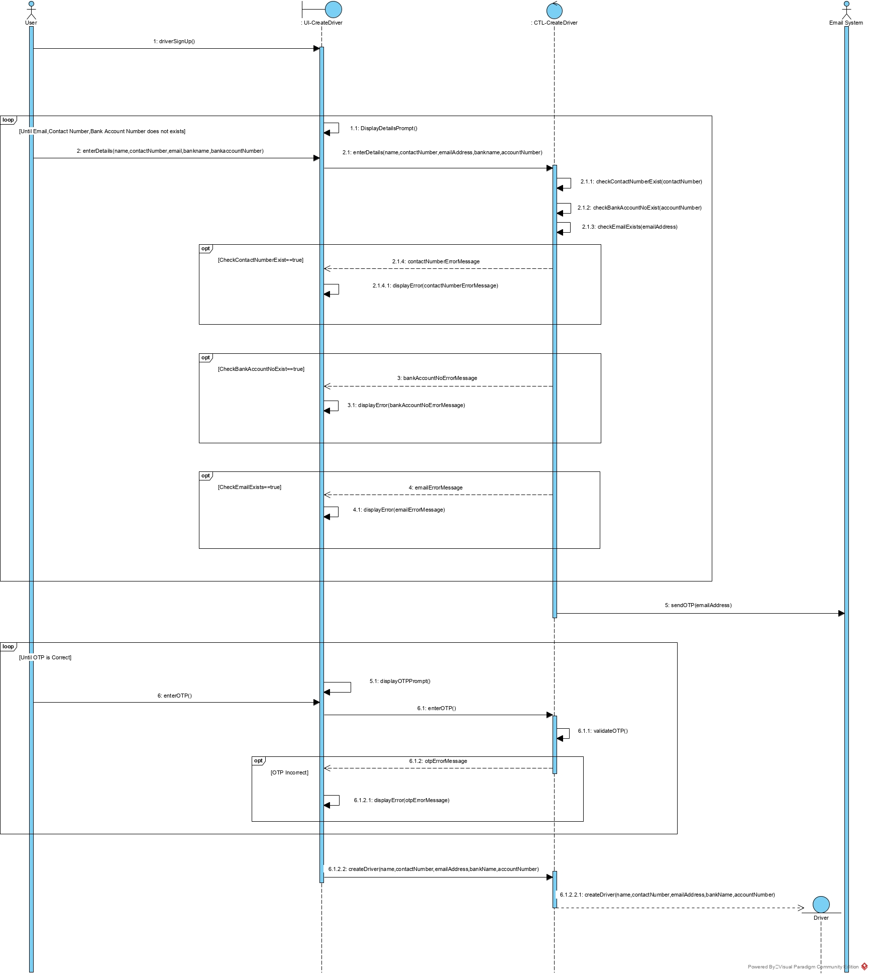

Student Name:Lim Dao Jun

Student ID:S10195591K

## Driver Accept Customer Booking

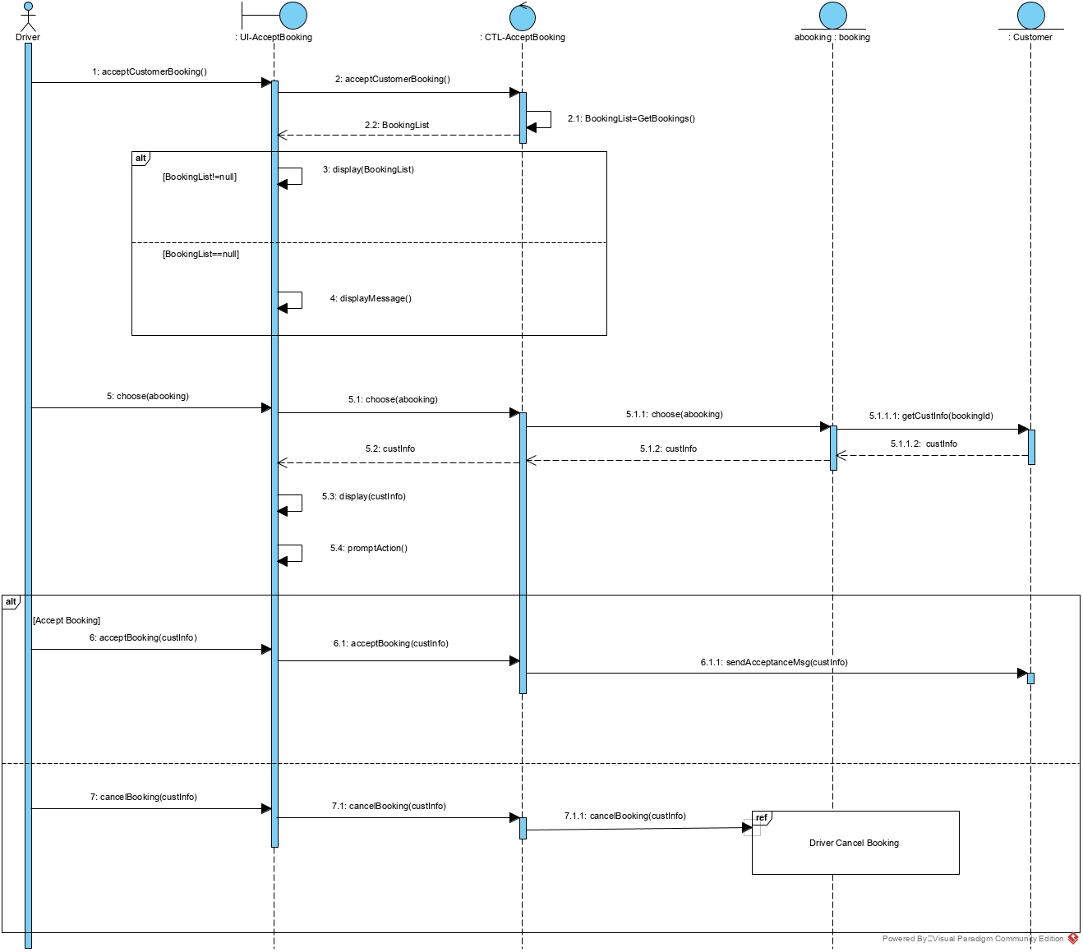

Student Name:Lim Dao Jun

Student ID:S10195591K

## Create Customer Account

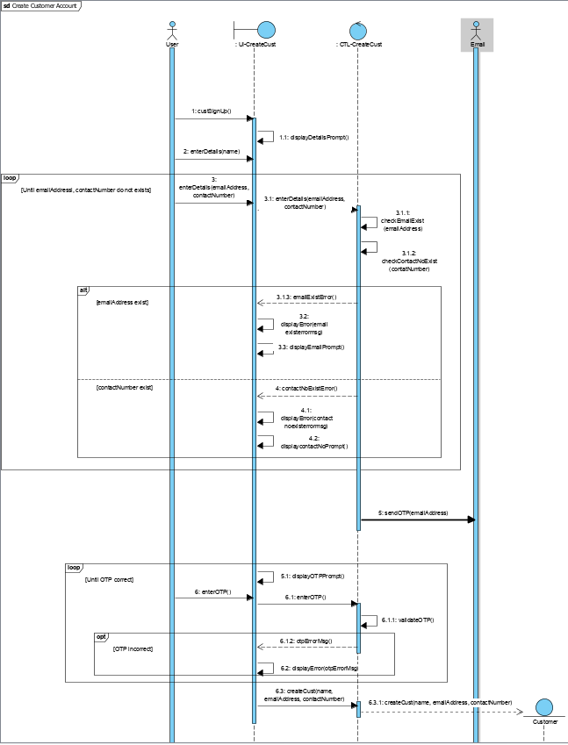

Student Name: Lee Sutton

Student ID: S10195583E

## Make Booking

Student Name: Gerald Tan

Student ID: S10196210C

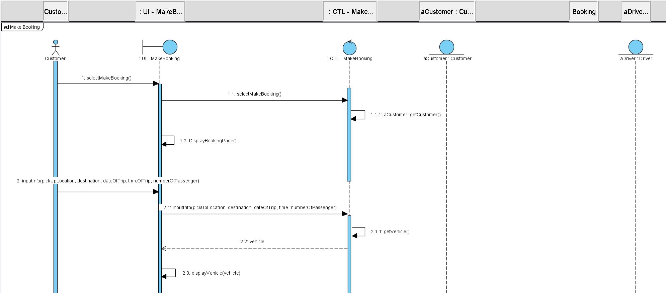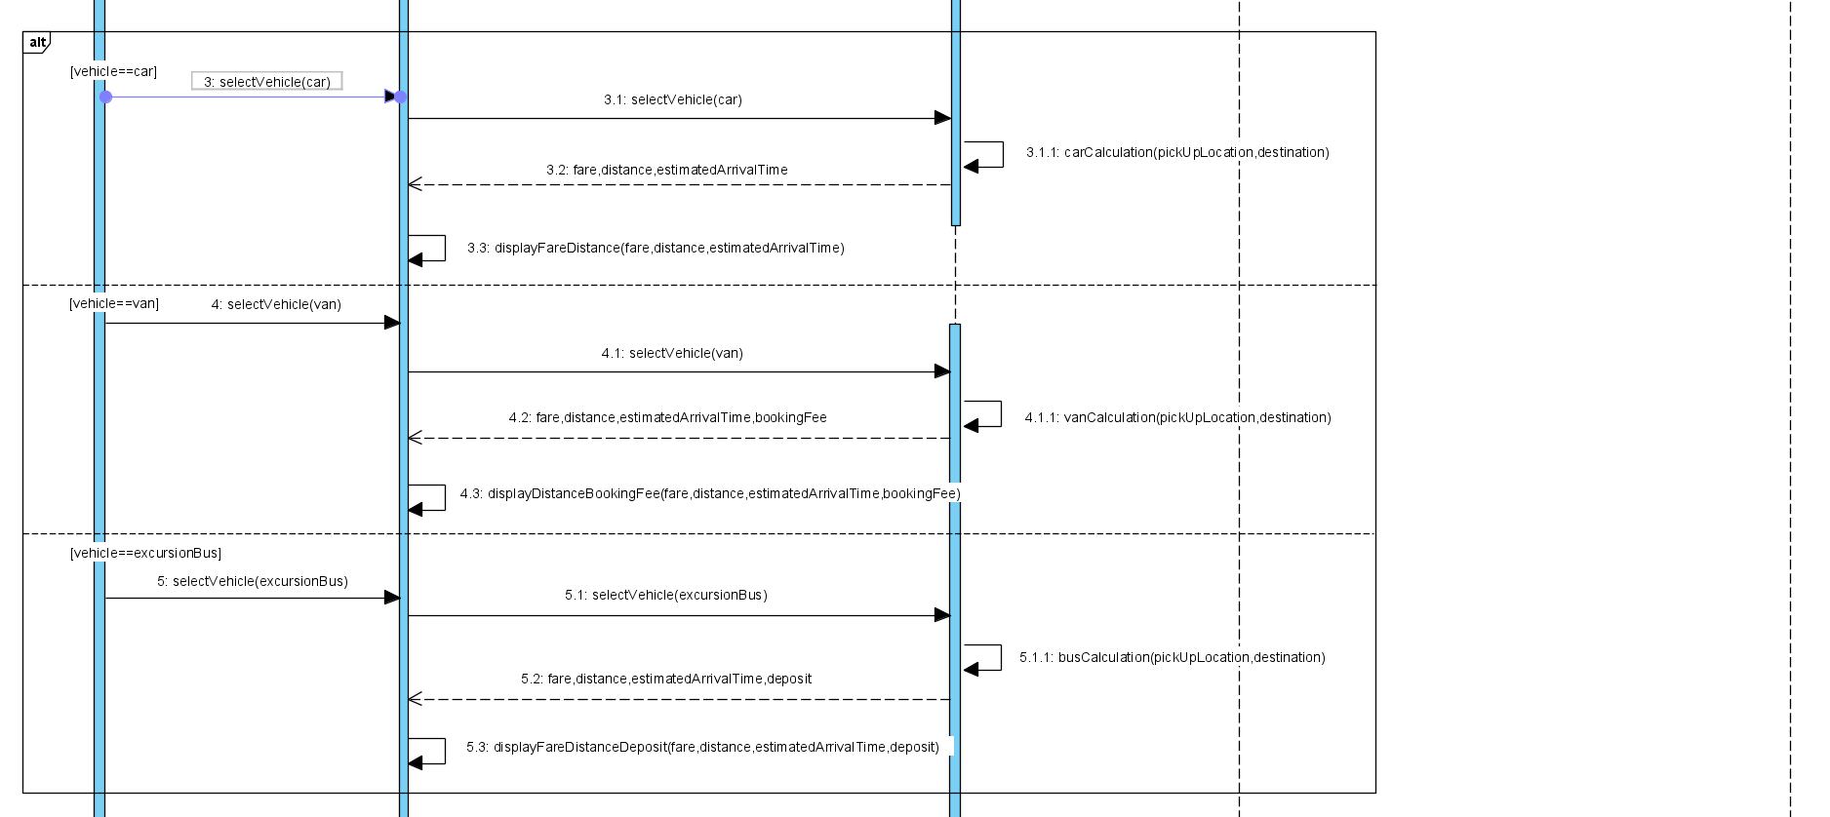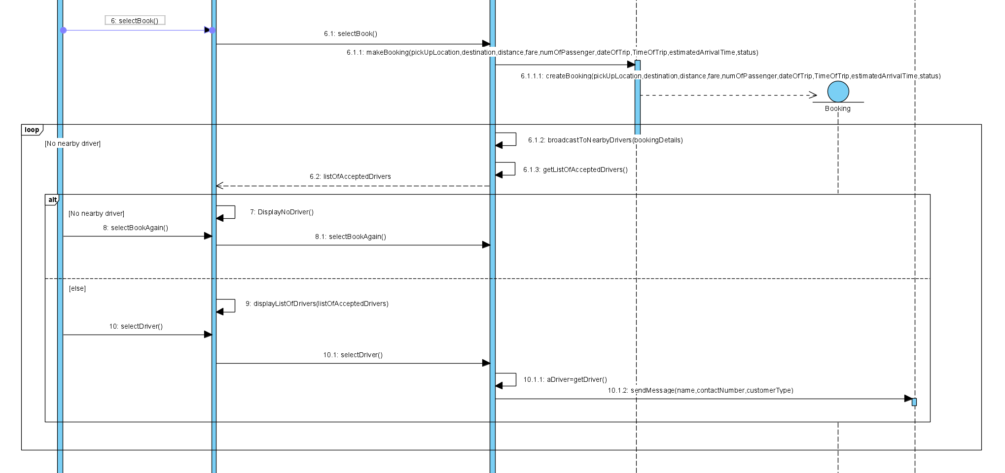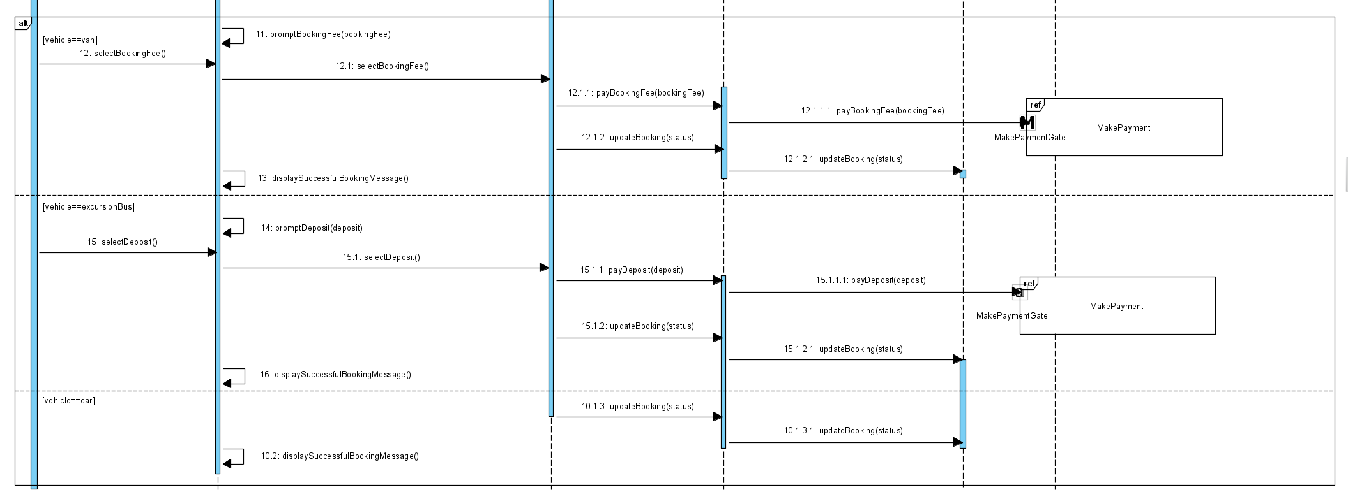

## 

## Make Payment

Student Name: Fong Kai Liang

Student ID: S10196491H

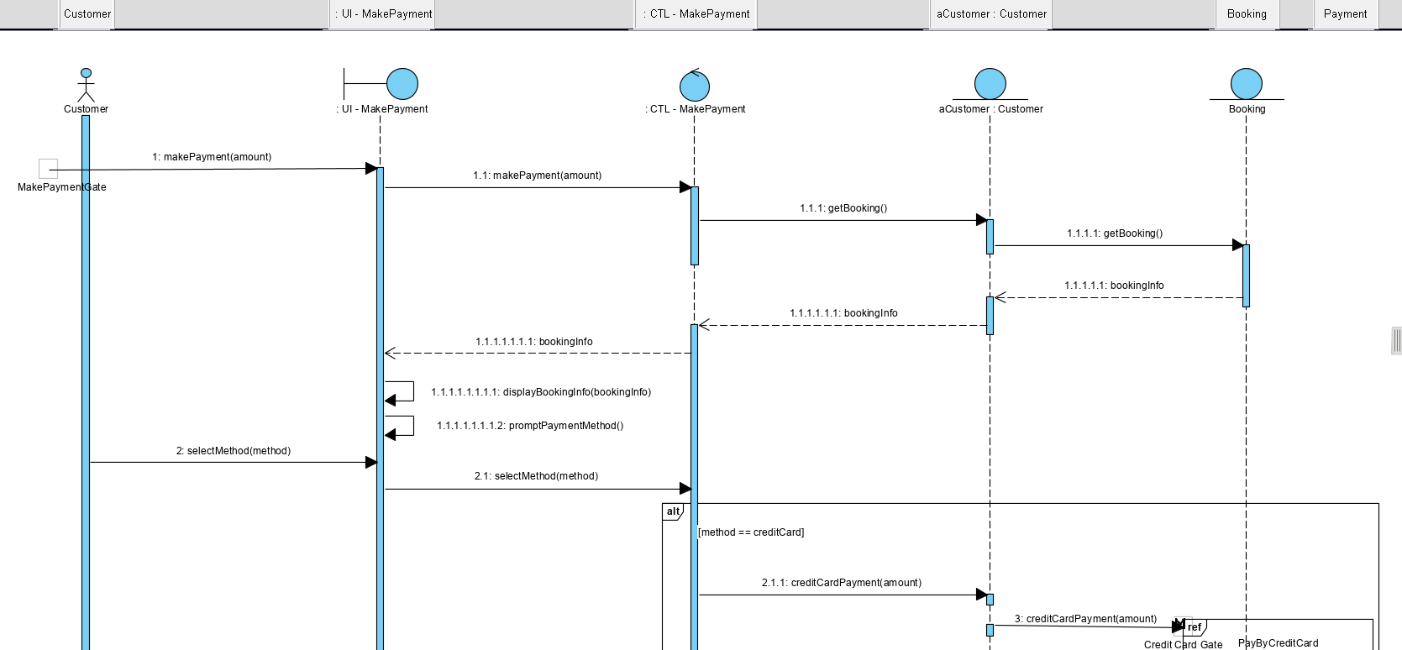

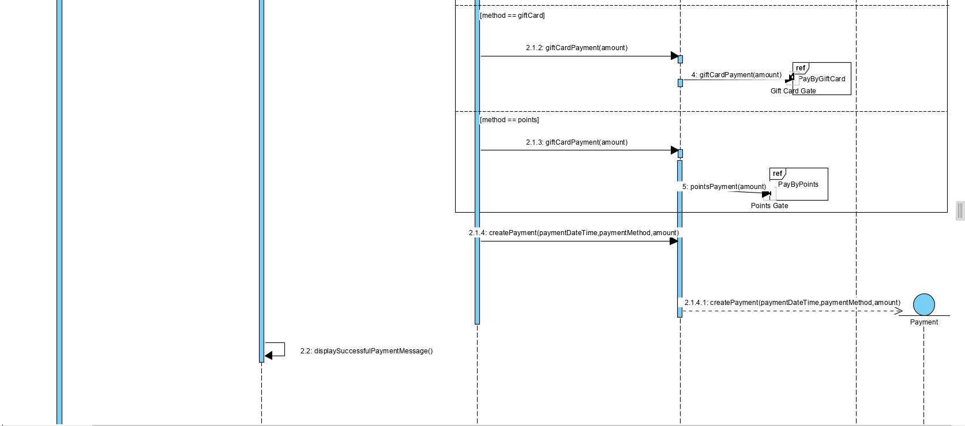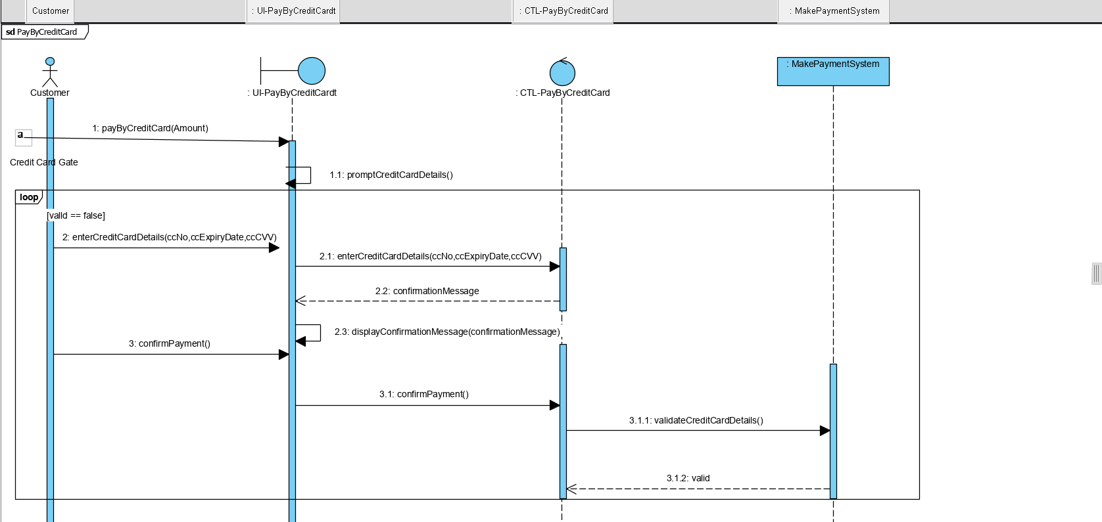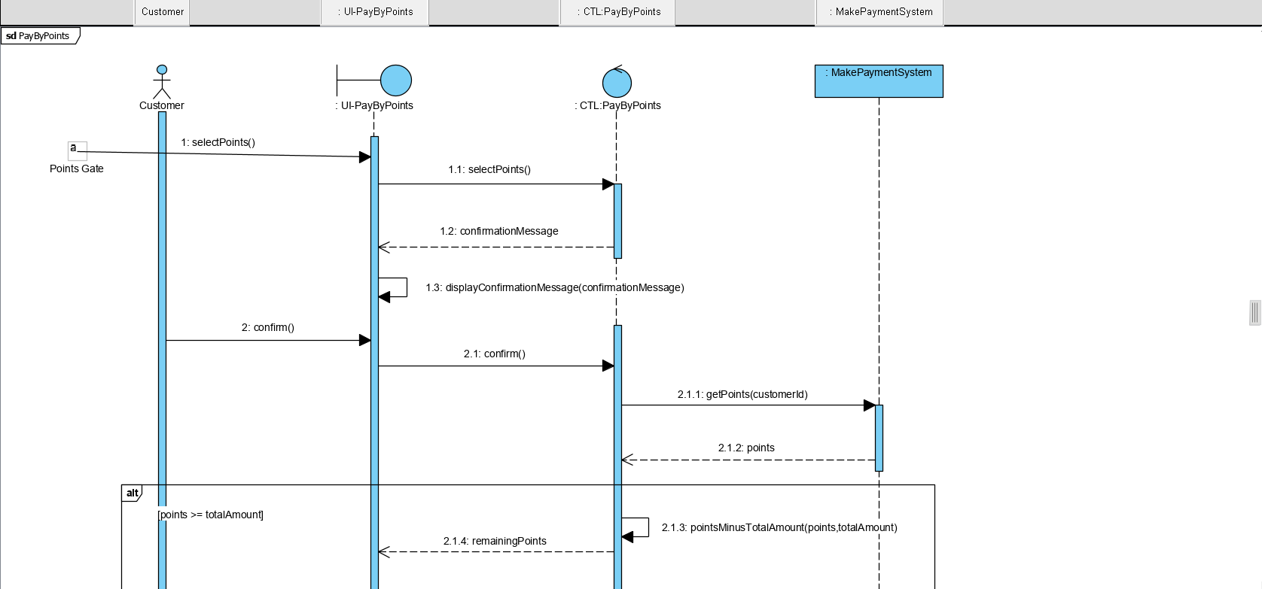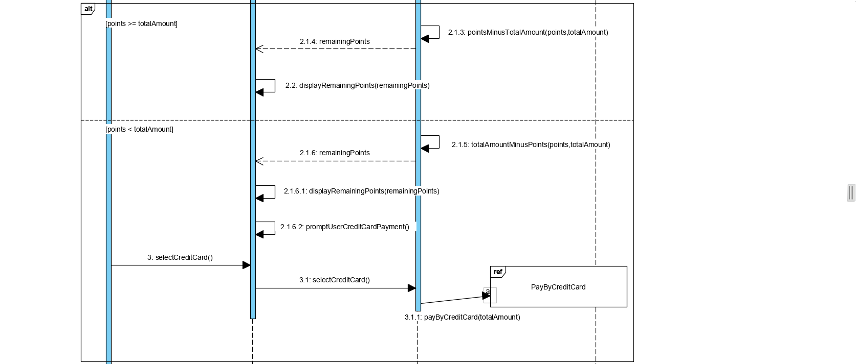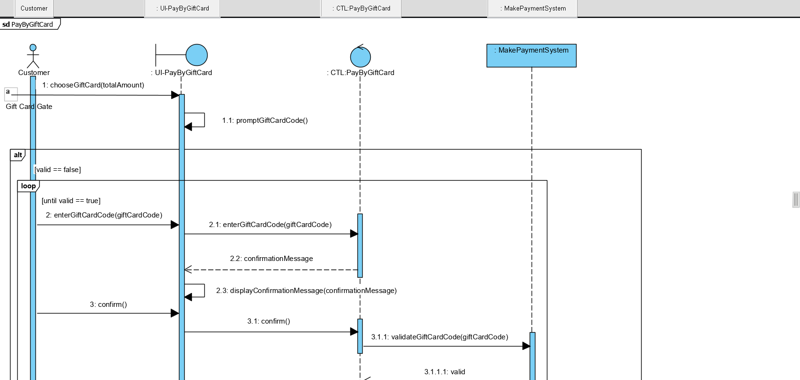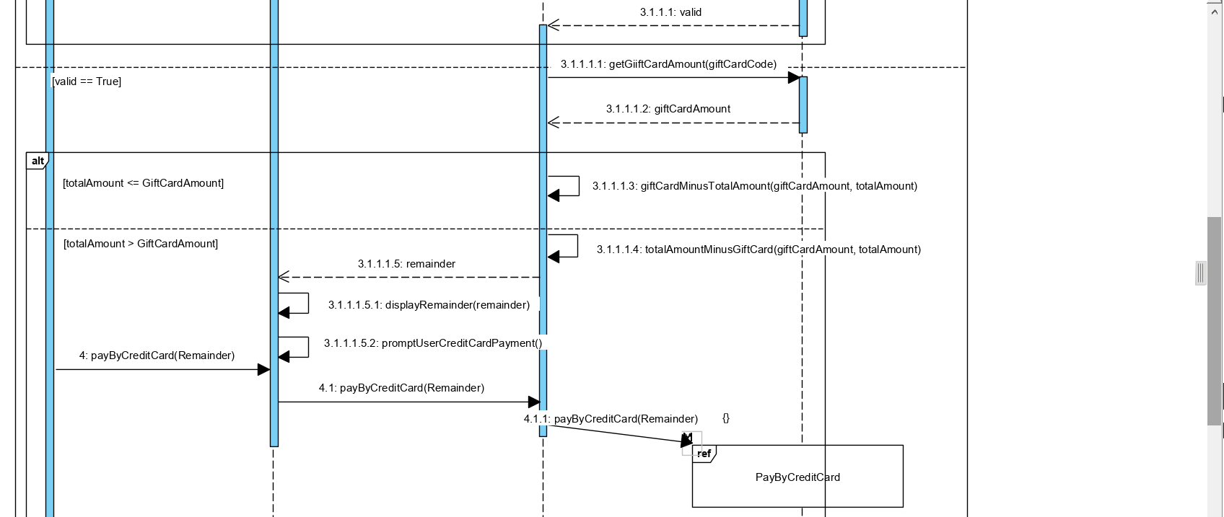

## Cancel Booking

Student Name: Anderson Loke Hou Ming

Student ID: S10195290

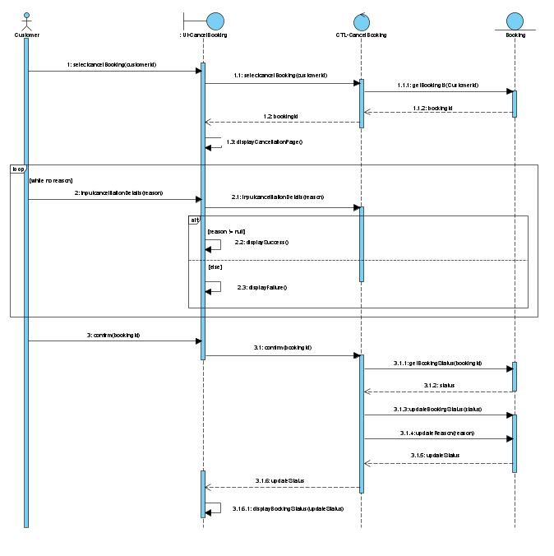

## Driver E-wallet

Student Name: Anderson Loke Hou Ming

Student ID: S10195290

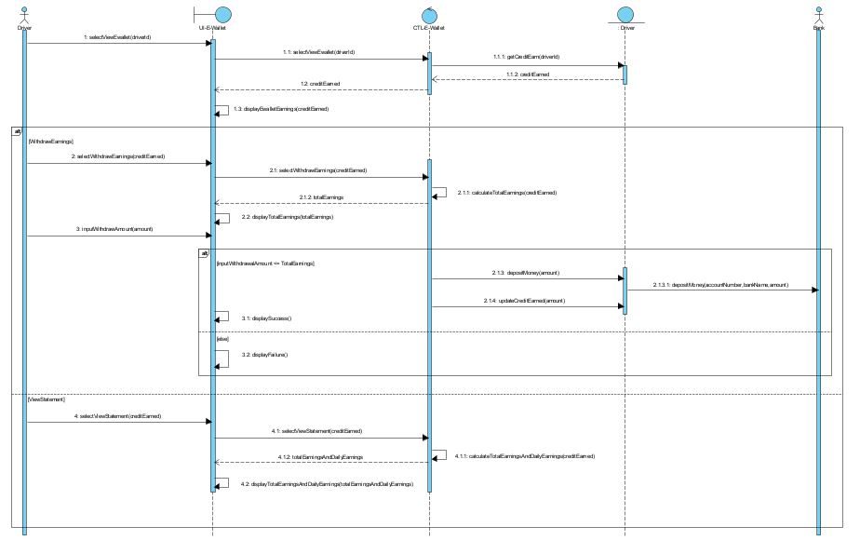

# 

# 

# 

# 

# 

# 

# Appendices

# Appendix A – Interview Guide

|  |  |  |
| --- | --- | --- |
| Interviewers: Gerald, Dao Jun, Anderson, Lee, Kai Liang  Interviewee: Dr Pamela Loy  Date : 2 June 2020  Time : 5.30PM-6.00PM  Place : MEL  Subject : To clarify and gather as many details as possible about the problem statement, and any additional requirements. | | |
| **Time**  **Allocated** | **Interviewer**  **Question or Objective** | **Interviewee Response** |
| **5.30-5.32** | **Introduction** |  |
| 5.32- 5.40 | **Accounts** |  |
| 2 min | **Question Owner**  *(Gerald)*    **Question 1**  Are drivers allowed to pick up customers from more than 1 account? Eg. Grab Share    **Follow up question**  If yes, Up to how many people for each vehicle? | Q1. No, 1 customer can only have 1 account and 1 driver can only pick up 1 customer account. |
| 1 min  5 min | **Question Owner**  *(Dao Jun)*    **Question 1**  Can a vehicle be registered under multiple drivers?    **Follow up question**  Is this the same for the different vehicle types?  **Question Owner**  (KL)  **Question 1**  can users create multiple accounts using the same phone number or email address  **Follow up question**  What is the maximum number of accounts a user can make?  **Question 2**  What happens if a driver registered a vehicle but has a new one he wants to use to drive?    **Question 3**  Is the company able to use PickUpNow Taxi as a user?    **Question 4**  Is it ok for more than a single user to share the same bank account?    **Question 5**  Are the identification numbers assigned to drivers and customers the same?  **Follow up question**  If not what kind of patterns do they have? | Q1:No,One Vehicle to One Driver.  Yes it is the same for different vehicle types.One driver should only have one vehicle whether its a bus ,van or car.  Q1: No, that would be something unique    Q2: He would have to update vehicle  Q3: Customer base?  Q4: yes don't care about bank acc  Q5: Identifiable based on first few letters if its a customer acc or a driver acc |
| 5.40- 5.48 | **Vehicles** |  |
| 1 min | **Question Owner**  *(Gerald)*    **Question 1**  Is there a booking fee for cars?  **Follow up question**  For example, when a customer books an excursion bus, there is an upfront deposit amount. When a customer books a van, there is a booking fee that will be added to the fare. | No. There is no booking fee for cars. |
| 1 min | **Question Owner**  *(Lee)*  **Question 1**  Are drivers only allowed to register one vehicle under their name?  **Follow up question**  How many vehicles can be registered under their name? | 1 vehicle only, even different types |
| 5 min | **Question Owner**  *(Dao Jun)*  **Question 1**  Can a driver cancel a Customer’s booking?    **Follow up question**  If so, what happens for the different types of vehicles?  **Question 2**  What happens when a customer cancels a Van booking?  **Follow up question**  Will there be anything recorded in the system?  Is it the same for cancelling car booking? | Q1: Can cancel, the booking will be available to take up the booking.Deposit and Booking Fee to be returned to the customer.  Q2:Booking Fee to be returned back to the customer.  Cancel within 24 hr the company keeps the booking fee  Name of Driver recorded when he cancels.  Yes It is the same. |
| 1 min | **Question Owner**  *(Anderson)*  **Question 2**  What is the maximum number of people in each vehicle?(vans and excursion buses) | Q1: Capacity of vehicle has to be stated |
| 5.48-5.50  N to n min | **Rides/E-Receipt** |  |
| 1 min | **Question Owner**  (Kai Liang)  **Question 1**  What does the e-receipt that is sent to the customer include? | 1: Information abt ride,start destination,how much it is, date and time. |
| 1 min | **Question Owner**  *(Gerald)*    **Question 1**  Why do you think the e-receipt sent to the customer’s email account instead of their contact number?  **Follow up question**  **Won't it be easier for the customer to check a phone message instead of an email as the customer might have multiple emails.** | Q1. Reason being it's more cost efficient. |
| 5.50-5.53  N to n min | **Points** |  |
| 1 min | **Question Owner**  *(Gerald)*    **Question 1**  How much point does the customer get after a $30 ride?/ how many points is equivalent to $30? | Q1. 1km of the trip is equivalent to 5 points. |
| 1 min | **Question Owner**  *(Dao Jun)*    **Question 1**  Can a normal Customer use points if it does not cover the bill in full? | Q1.No, you cannot do partial payment. |
| 1 min | **Question Owner**  *(Lee)*  **Question 1**  Do the customers get penalised for cancelling the booking?  **Follow up question**  Does it affect their points as a customer? | No |
| 1 min | **Question Owner**  *(Anderson)*  **Question 1**  How are the points used to pay their bills?  **Follow up question**  What discounts are available? | Q1.$2 = 300 points |
| 5.53-5.55  N to n min | **Ratings and Feedbacks** |  |
| 1min | **Question Owner**  *(Lee)*  **Question 1**  Do the drivers get penalised for cancelling the booking?  **Follow up question**  Does it affect their ratings as a driver? | Q1.No |
| 1 min | **Question Owner**  *(Dao Jun)*  **Question 1**  Will the number of stars a driver be recorded in the system? | Q1.Yes.Average score to be recorded. |
| 5.55-end of interview  N to n min | **Reality Questions** |  |
| 1min | **Question Owner**  *(Lee)*  **Question 1**  How do customers find their drivers?  **Follow up question**  Are they based on location or just if a driver decides to accept their request?  **Question 2**  Is there a maximum waiting time?  **Follow up question**  For example, if a GrabTaxi driver has to wait for more than 5 mins, additional fees are applied, so will there be additional fees added? | Q1.Customer to specify current location , destination and date time. System to calculate charge for him and let customers accept. Once accepted , the customer will be broadcasted to all drivers.  Q2.No penalisation for waiting times |
| 1 min | **Question Owner**  *(Gerald)*    **Question 1**  Do drivers have any incentives?  **Follow up question**  Maybe you can explain a bit more about it?  **Question 2**  What are your thoughts on maintenance of each driver’s vehicles? | 1. No incentives as it is a small business, just started. 2. Drivers will take the ownership to maintain their own vehicles. |
| 3 min | **Question Owner**  *(Dao Jun)*  **Question 1**  How does the customer make payment for the trip?  **Follow up question**  What are the different modes of payments?  Would transaction information be recorded?Does anything happen to transaction information? | Q1.customer make payment through credit card , Gift Vouchers and Points. We don't accept cash. Gift voucher given out by the Company or could be bought for personal use or as a Gift.  Customers should be able to see the history of rides and transaction information in there. |
| 5 min | **Question Owner**  *(Anderson)*  **Question 1**  What are the departments in the company?  **Question 2**  Is there customer service?  **Follow up question**  Please share what they do specifically?  **Question 3**  Can one customer book multiple drivers?  **Follow up question**  If so, what is the maximum amount?  **Question 4**  What are the ways your staff would interact with the system (manage drivers)?  **Question 5**  Are there different rates? | Q1: Call hotline  Q2: Yes. Help answer enquiries  Q3: No  Q4: Does Not interact with the system  Q5: Rates depend on capacity on vehicle base rate is $5 per unit  $1 per capacity  distance travelled every km $2 time midnight and peak hr and lunch time charge  Non peak - $5  peak-$10 |
| 5 min | **Question 1**  **What other functions do you want us to implement?**  **Follow up question**  **Please share what you want each function to do** | E-wallet for customer and driver  E-wallet to keep points for customer  Shows the customer the currency exchange rate for points to dollars |
| **General comments and Notes:2 min left**  Can propose new features that weren't covered in the interview provided that it is covered in the background reading  **Things that are bad about the interview**   * The style of asking question was confusing for the interviewer * Didn’t ask permission for recording * Didn’t tell interviewer what we know about the system   **Things that are good about the interview**   * Did not ask alot of close ended question * Make the Interviewer talk a lot   **Things that could have do better during the interview**   * one person take one topic so that when interviewing it's not very messy * Could have asked more probing and follow-up question * Should have ask permission to record before the interview * Can start of the interview by telling the interview what we know * Can ask about how the current system is doing * Do a summary of the whole interview * Can ask for a bit more time to summarize the whole interview | | |

# Appendix B – Background Reading Notes

Referencing similar companies, like ComfortDelgro, we can find features that could be incorporated into PickUpNow Taxi’s system.

ComfortDelgro has their own booking service, ComfortRIDE. Their service offers a way for customers to find vehicles closest to them and pay for fixed fares. During peak hours, their system is more efficient as there will be more taxis on the road, and customer waiting times will be shortened. Customers can choose between metered or fixed rates depending on demand.

ComfortDelgro also has a convenient in-app payment system called NETS Click, in partnership with NETS. Passengers will be able to use their NETS bank cards to pay for mobile booking in-app itself, making it more seamless and convenient for the customers.

These features are possible features that could be useful to include in PickUpNow Taxi’s system.

# The vision of ComfortDelgro is “To be the world’s land transport operator of choice”.

ComfortDelgro Taxi Booking App has a booking service called ComfortRIDE which was released on 7 may 2019. The aim of ComfortRIDE is to meet the demand especially during peak hours.This service connects passengers to the nearest vehicle and also allows passengers to book rides with fixed fares set based on demand at the time of booking. With more taxis on the roads during peak hours, commuters will be confirmed a vehicle faster and their waiting time will be reduced. Moreover, passengers who use the App can choose between the traditional metered taxi option which the fare will be metered rate or the new ComfortRIDE option which the fare will be a fixed rate depending on the demand at the point of time. This can be a possible functional requirement to allow customers to get a taxi faster.

ComfortDelGro and NETS launched a convenient in-app payment method called NETS Click, allowing the passengers of ComfortDelGro taxi to use their NETS bank cards to pay for mobile booking and street hail trips. This payment method is convenient and seamless as the passengers can securely add their NETS bank card to the ComfortDelGro Taxi Booking App. This can be a possible functional requirement to allow customers to make payment if they don’t have their wallet with them.

# 

# Appendix C – Other Tools Used

We use Visual Paradigm as it is a software tool designed for software development teams to model business information systems and manage development processes. Visual Paradigm supports key industry modelling languages and standards such as Unified Modelling Language (UML), SoaML, BPMN, XMI, etc.

We also use StoriesOnBoard.com which allows us to create a user story map. User Story Map is used to make a new story using mapping tricks and techniques